**CPU**

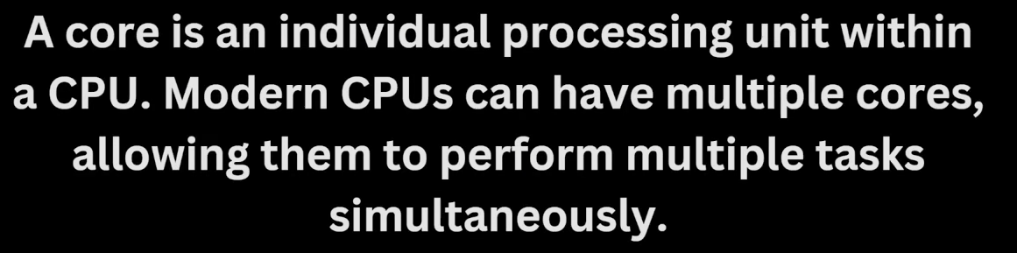

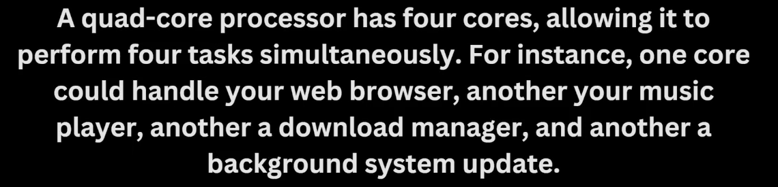

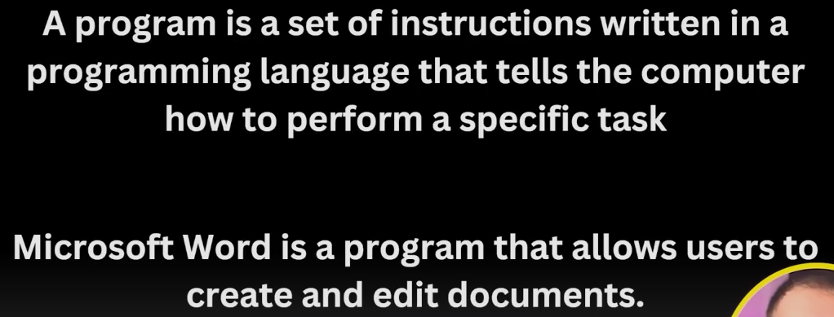

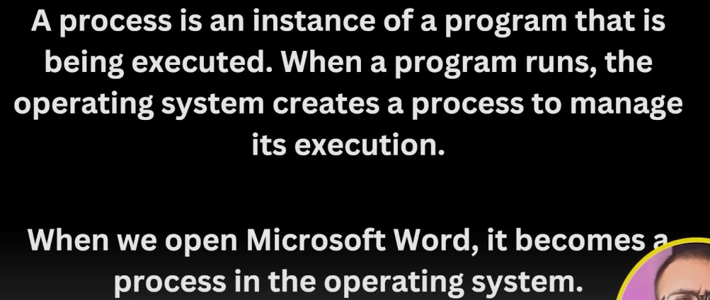

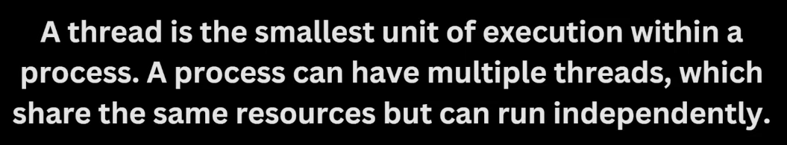

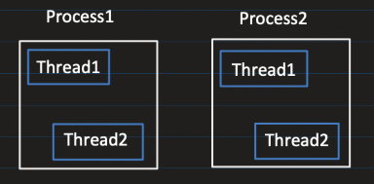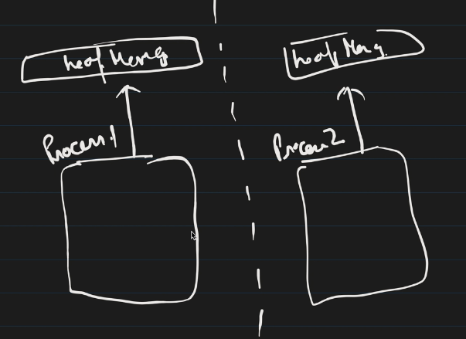

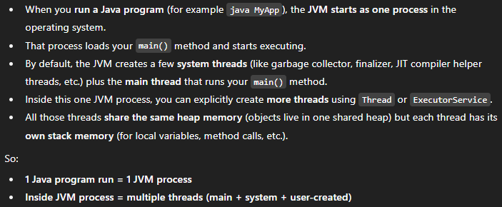

If you run: 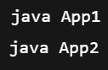You now have **two JVM processes**, each with: its own heap, garbage collector, its own thread stacks and metaspace. The bytecode is executed inside this JVM process

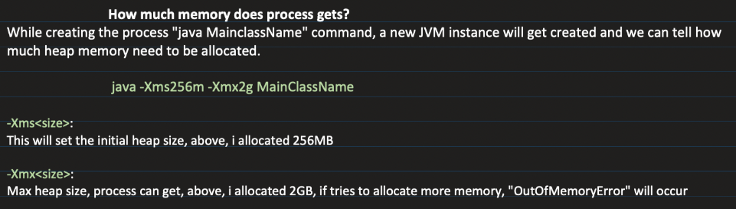

Using **-Xss2m** we can configure maximum stack size per Java thread. StackOverflowError if it exceeds.

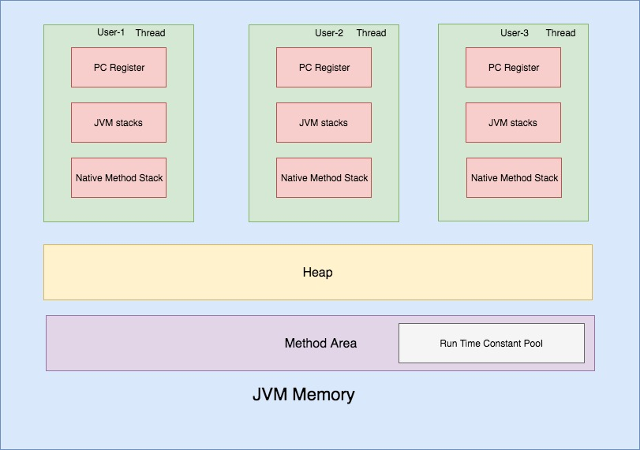

**PC register 🡪** stores the address of JVM instruction currently being executed for any particular thread. It points into the method’s bytecode stored in the Metaspace. It used during context switching.

For **native methods**, PC value is *undefined*

**JVM Stack** 🡪 A stack is created during a thread startup time. It stores **stack frames**. A new stack frame is created and pushed into a thread stack every time a method is invoked. A frame is popped when a method returns.

**Native method Stack** 🡪 Used when a thread executes **native (non-Java) code**

**Heap** 🡪 Objects created at runtime using “new” keyword are allocated in the heap and the stack stores the reference to it. The data stored in heap is not thread safe.

**Method Area / Metaspace 🡪** Once a class bytecode is loaded by a JVM class loader, the JVM creates an internal representation of the class and stores it in the *method area*. That internal representation of a class contains – method bytecode, attributes & field values, Runtime constant pool.

**Runtime Constant Pool** 🡪 It stores numeric constants, string literals symbolic references to methods and fields used in that particular class.

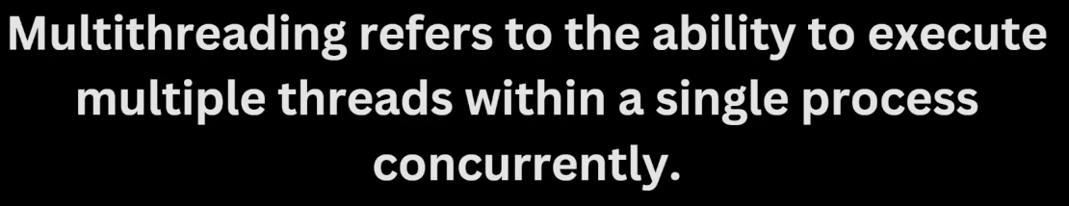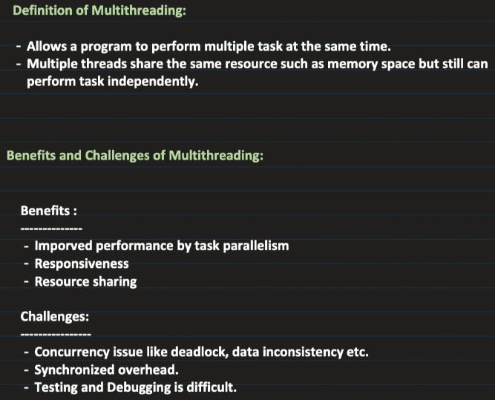

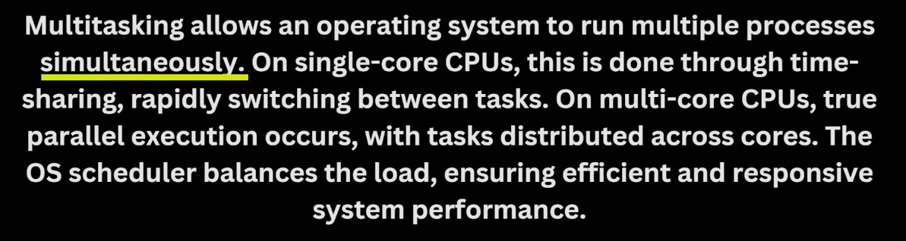

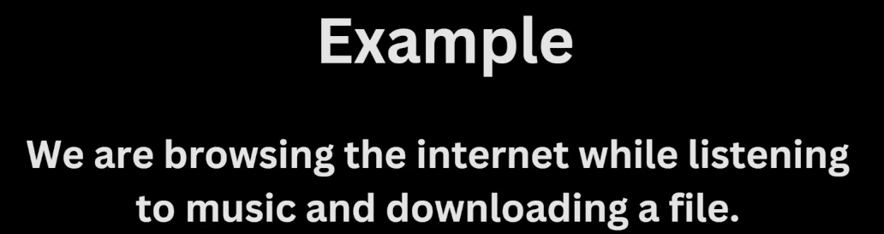

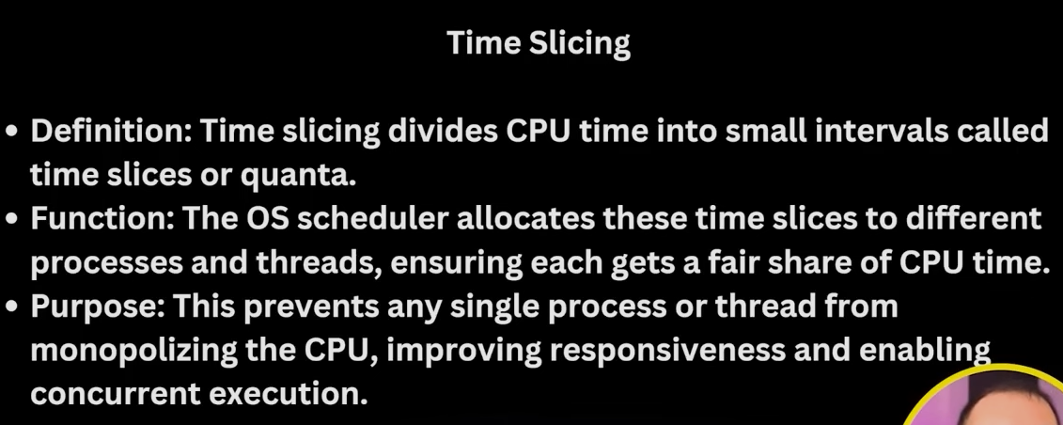

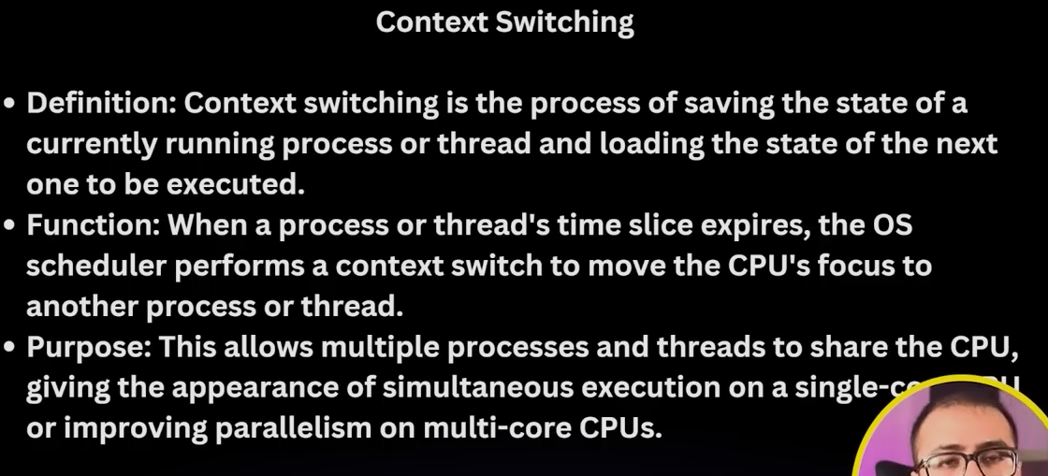

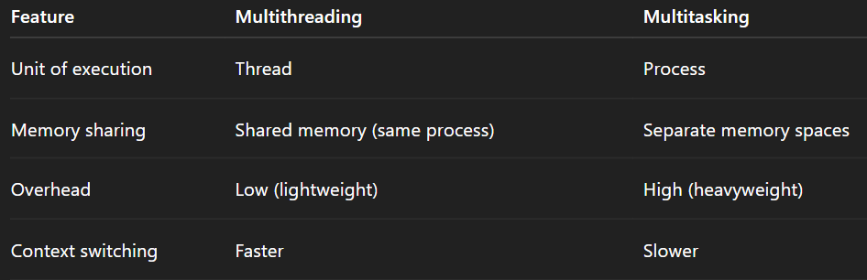

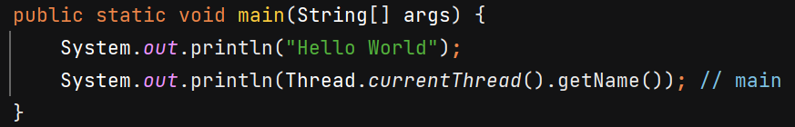

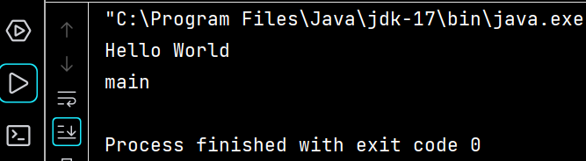



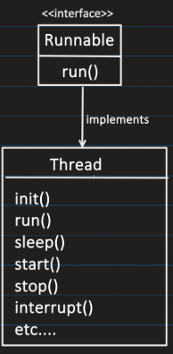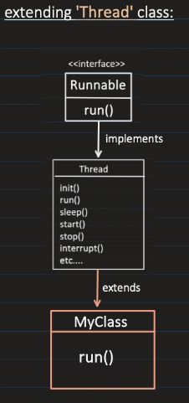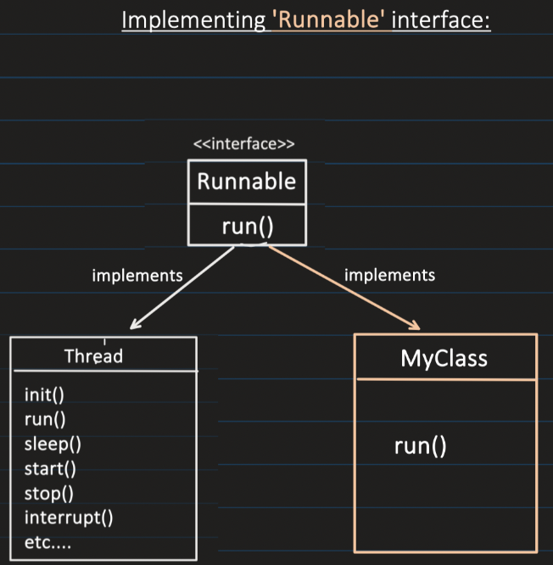

**Method 1 –**

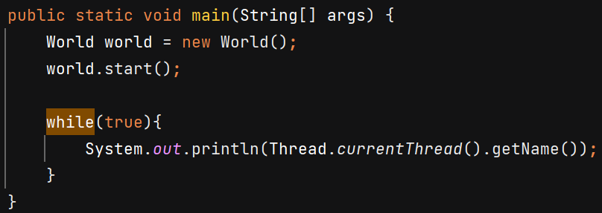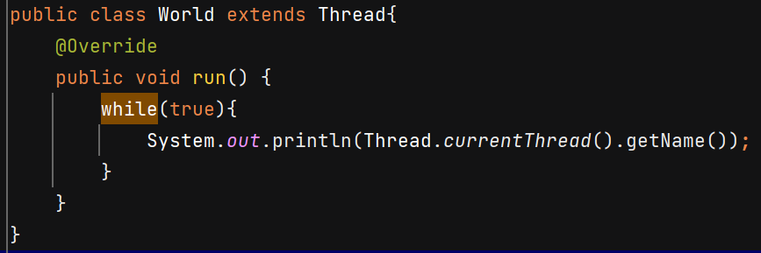 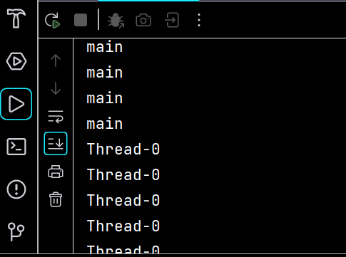

**Method 2** –

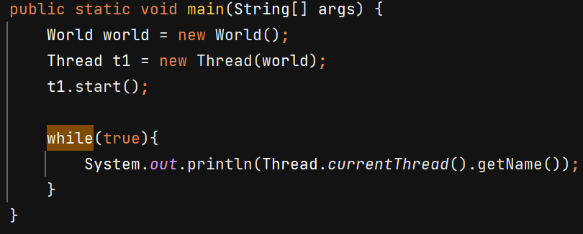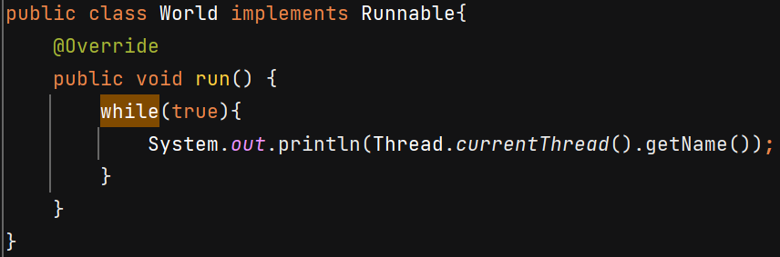



When we call the start() method, internally it calls the run() method of Thread class.

**Thread Lifecycle**

**NEW:**When a new thread is created, it is in the new state. The thread has not yet started to run**.**

**RUNNABLE**: In this state, a thread might be ready to run or actually running.

**BLOCKED:** A thread is in **BLOCKED** state **only when it is trying to acquire a lock** that is currently held by another thread.

**WAITING state**: A thread enters waiting state when it waits indefinitely for another thread to perform an action. Ex- Object.wait() / Thread.join() and moves to runnable after notify() / notifyAll() / thread completion

**TIMED_WAITING**: A thread enters Timed Waiting when it waits for a fixed amount of time. Ex- Thread.sleep(), join(timeout), wait(timeout) and moves to Runnable when timeout expires.

**TERMINATED**: The thread has completed execution.

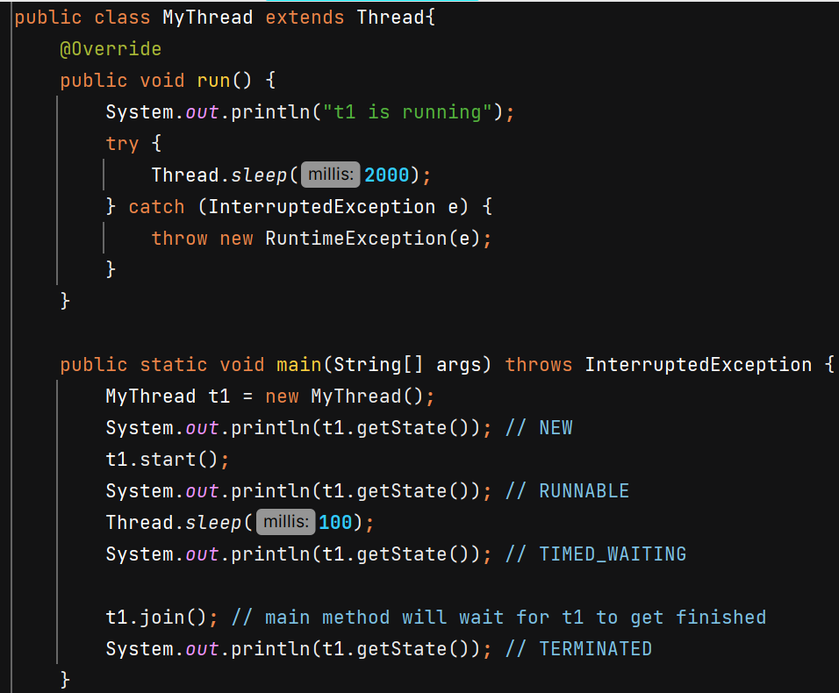

**Thread v/s Runnable**

Suppose class A already extends class B in that case we cannot extend it by Thread class also because multiple inheritance is not allowed, in this case class A should implement Runnable interface and override Run() method.

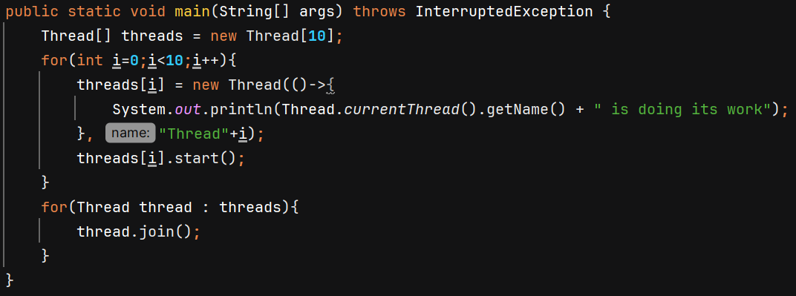

**join()** will make main thread to wait for t1 thread to complete its execution.

**join(timeout in ms)** 🡪 wait atmost given milliseconds for this thread to die else continue.

**Methods –**

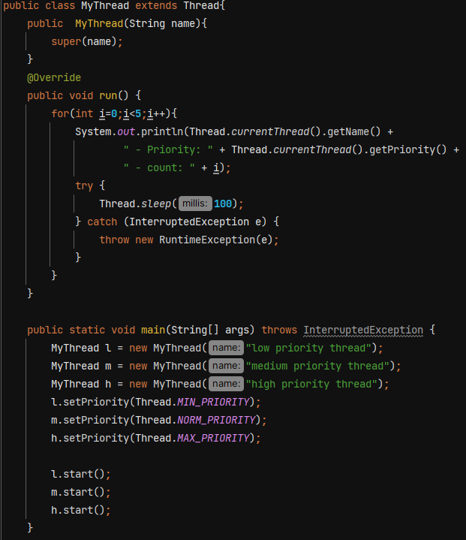

In constructor we can pass name of thread.

Using **setPriority(int priority)** we give hints to JVM about relative importance of threads; it is not strictly followed. Maybe thread with low priority execute earlier than thread with medium priority.

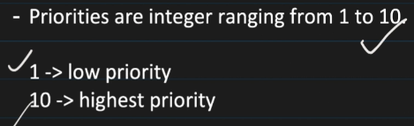

Priority of main thread is *NORM_PRIORITY* = **5**

When a new thread is created, it inherits the priority of its Parent method.

**interrupt()** – never kills a thread — it either throws an exception (blocked) or sets a flag (running), and the thread must cooperate.

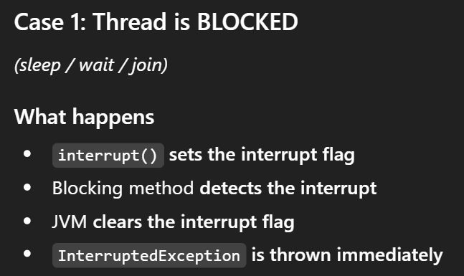 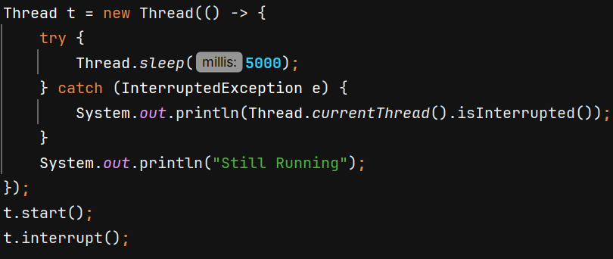

O/P 🡪 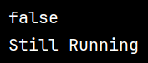

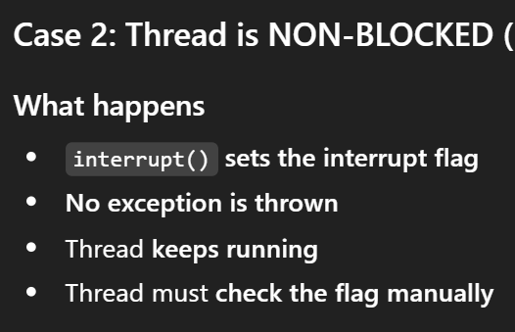 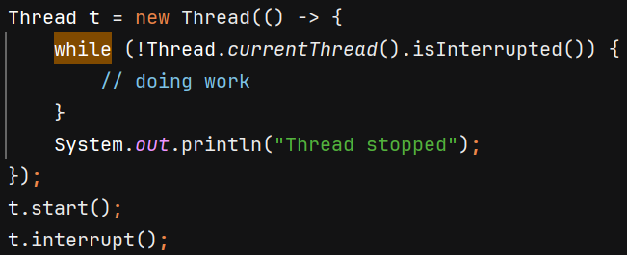

O/P 🡪 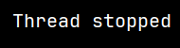

**Best practice** is to to re-interrupt the thread in catch block so that the interrupt flag that was cleared will be restored –

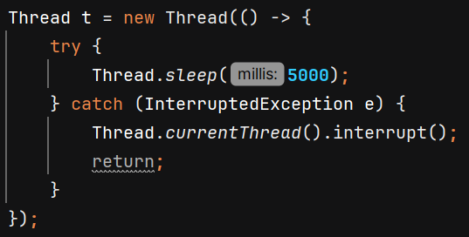

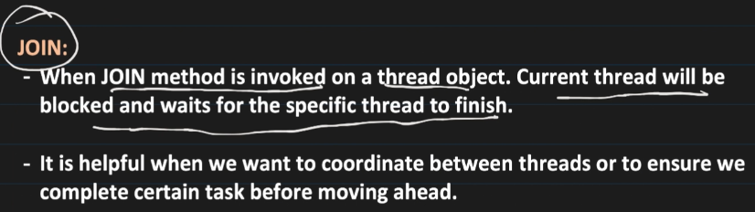

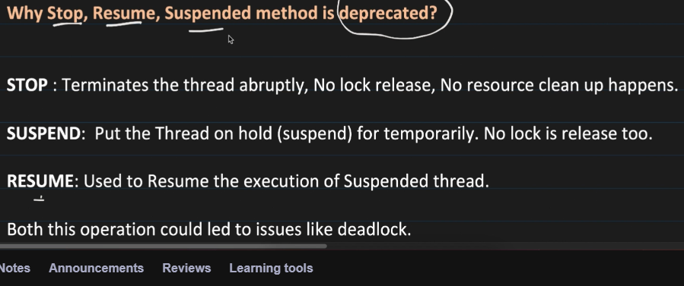

**Yield()** - Used to hint to the thread scheduler that the current thread is **willing to pause** its execution and **current use of processor**to let other threads run. The scheduler is free to ignore this hint.

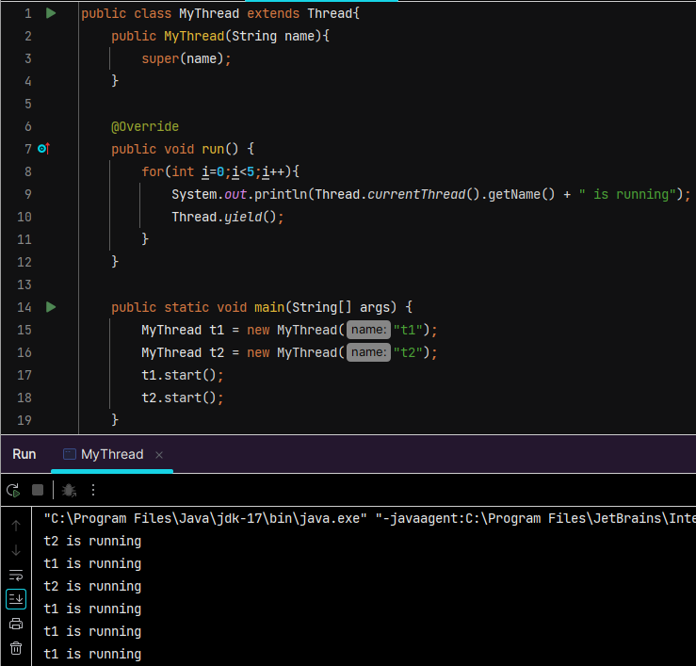

**User Thread** – Any **normal thread** that runs the application logic and business tasks.

The **JVM will continue running** as long as there is at least **one user thread** still active — it **waits for all user threads to finish** before shutting down.

**Daemon Thread** – they run in background. Ex- garbage collector in Java.

**JVM does not wait** for them to finish before shutting down. As soon as all the user threads are done, daemon threads are also terminated and JVM terminates.

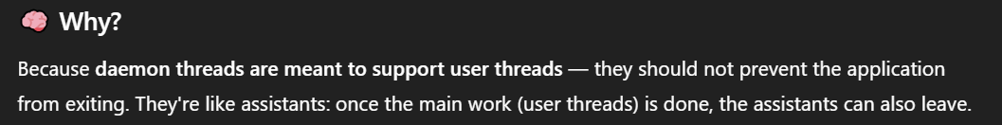

The daemon status of a thread can be set via **setDaemon(true)** but it must be configured before the thread is started.

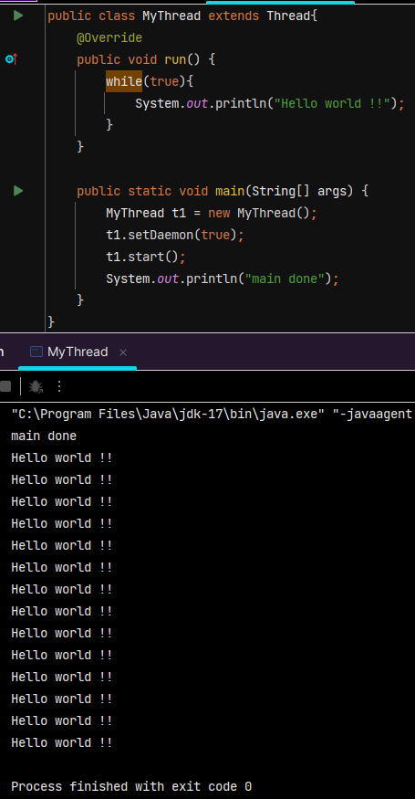 

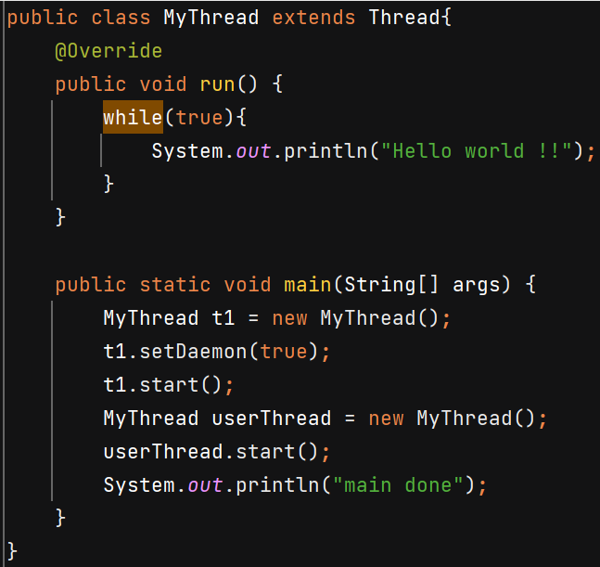

In this case both threads keep running and JVM will wait for userThread to finish.

**Synchronization**

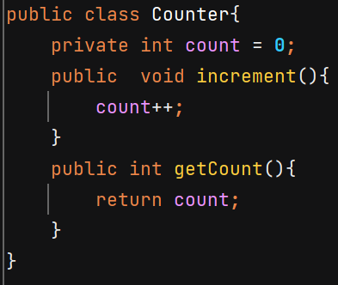 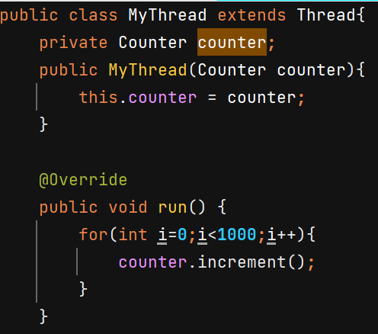

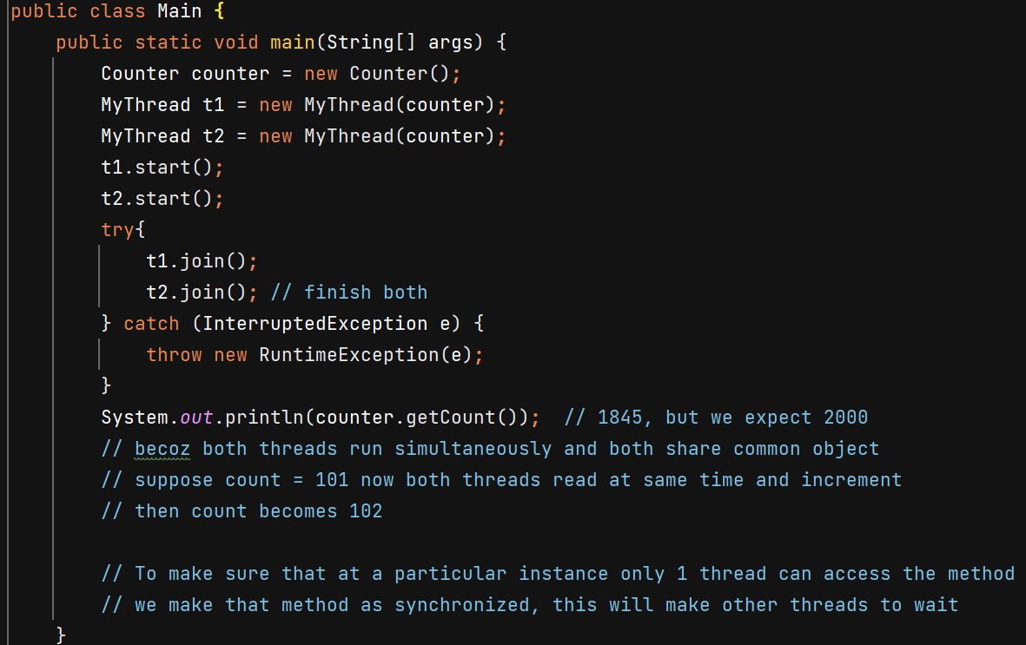

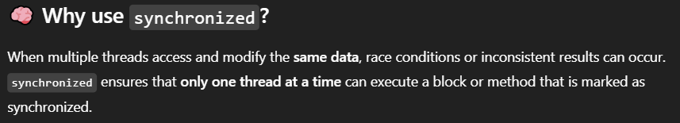

**Synchonized instance methods** 🡺 Only **one thread per object** can execute this method at a time. Monitor lock of that particular instance is acquired.

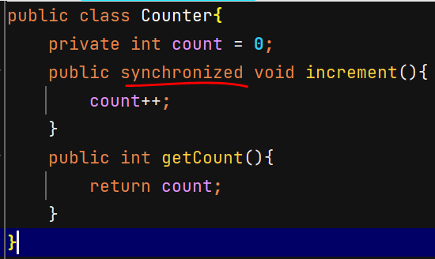 Now O/P – 2000

Instead of whole method we can make a particular **block synchronized** –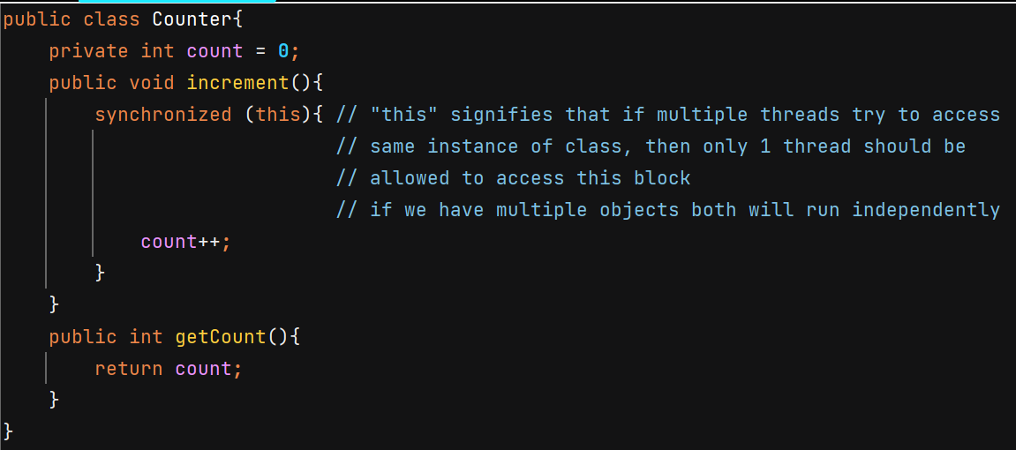

Both **synchronized(ClassName.class)** and a **static synchronized method** use the class-level lock – locks Class object.

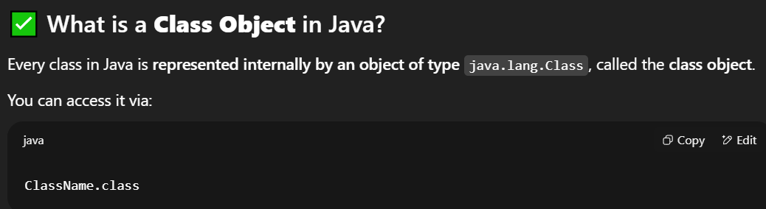

**synchronized(object)** 🡺 acquires intrinsic lock of that object

**Critical section** – Part of our code where shared resources are accessed and modified. Ex- increment() method in above example.

**Race Condition** – when multiple threads are working on shared resources and if their timing conflicts, it can lead to unexpected results and ambiguity.

**Mutual Exclusion** – condition that when only 1 thread can access the critical section

**Lock** is a concurrency control mechanism to prevent **race conditions** when multiple threads access shared data

Using synchronized keyword we achieve mutual exclusion and internally it is done by locking. When 1 thread is working on shared resource it aquires the lock and when it is done, it releases the lock.

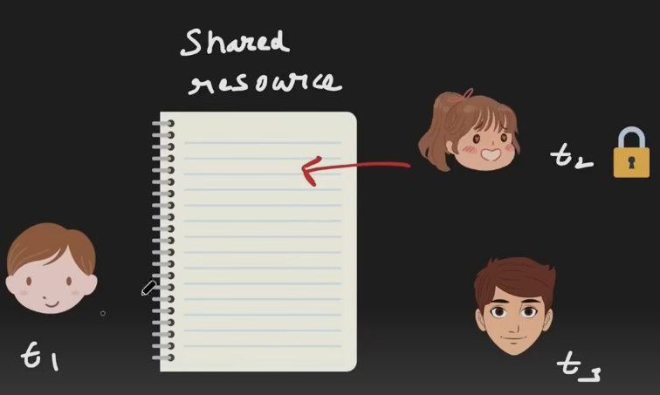

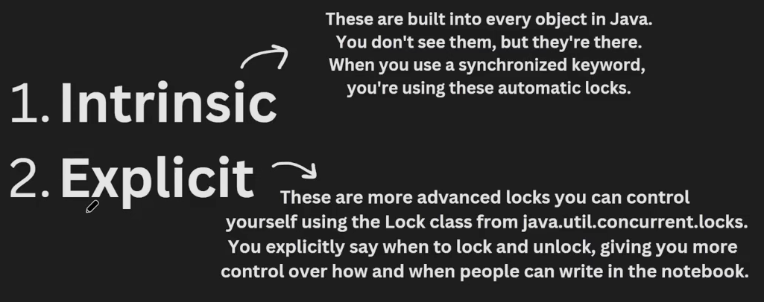

An **intrinsic lock** (or monitor lock) is a **built-in synchronization mechanism** that every Java object has. It helps to make sure that only 1 thread goes inside the particular seciton of code (synchronized block or method)

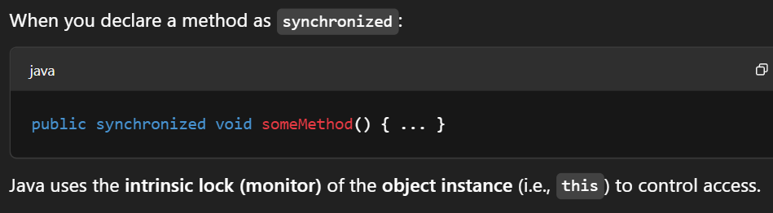

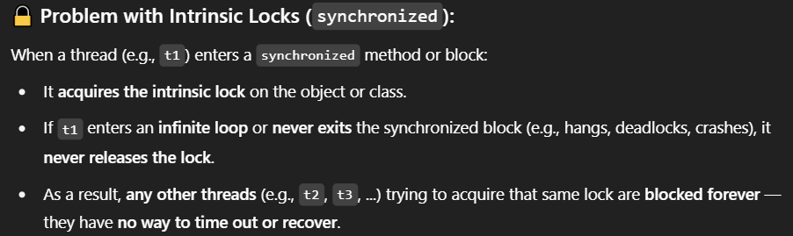

**You cannot interrupt a thread that is *blocked waiting to enter* a synchronized block or method in a way that wakes it up or stops the wait.**

If you call .interrupt(), then only interrupted flag is set to true but no exception is thrown 🡪 thread will keep waiting for lock.

Explicit locking can solve it.

**Lock** is interface and **ReentrantLock** is its impl class.

**lock()** 🡪 Acquires the lock **if available**, otherwise thread will wait for acquiring lock in BLOCKED state, just like synchronized.

**tryLock()** 🡪 Acquires the lock if it is available and returns immediately with the value true. If the lock is not available then this method will return immediately with the value false. Prevents deadlocks by not waiting forever.

**tryLock(1000, TimeUnit.*MILLISECONDS*)** 🡪 Acquires the lock if it is free within the given waiting time and the current thread has not been interrupted. If the lock is available this method returns immediately with the value true else false if timout expires.

**unlock()** 🡪 Releases the lock. Should **always be in a finally block** to ensure it’s released.

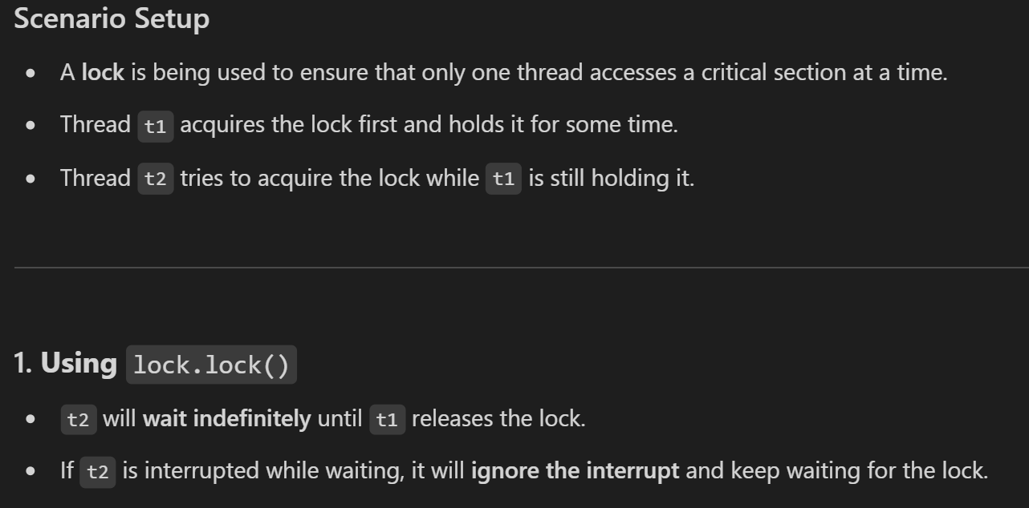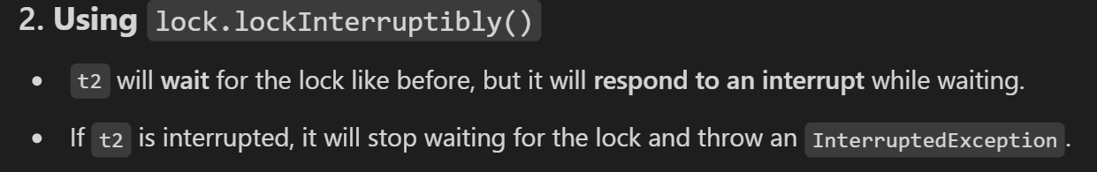

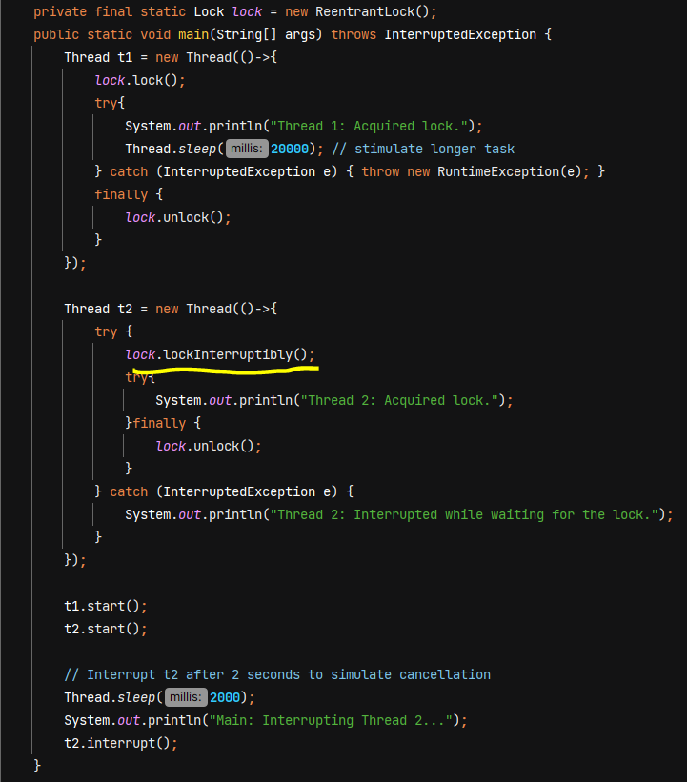

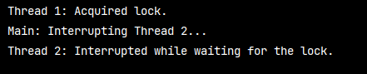

**Deadlock**

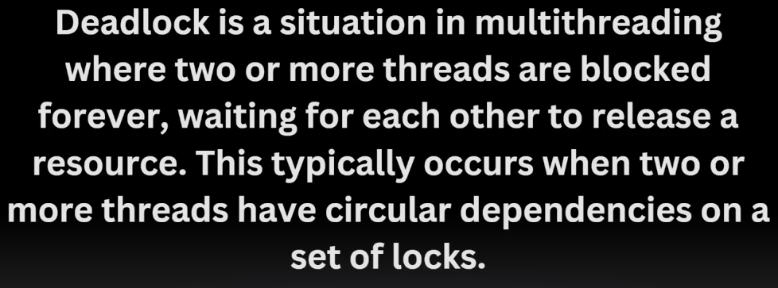

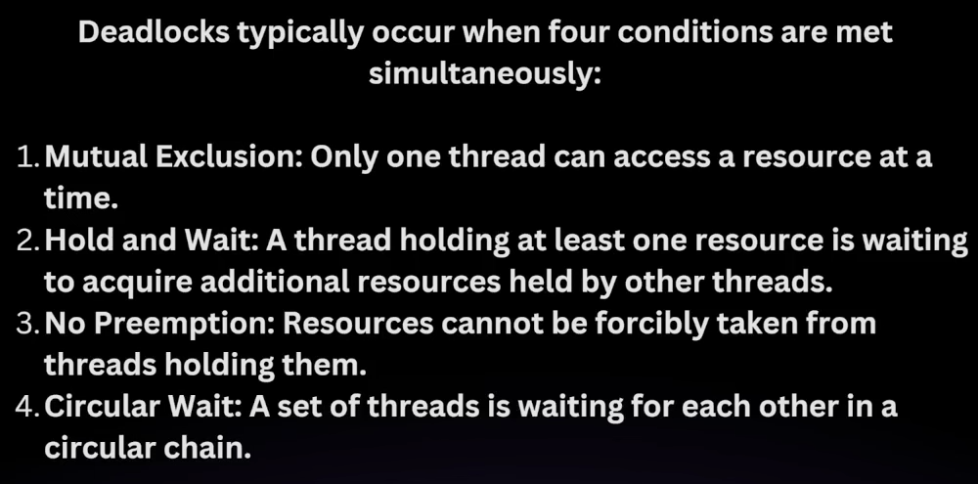

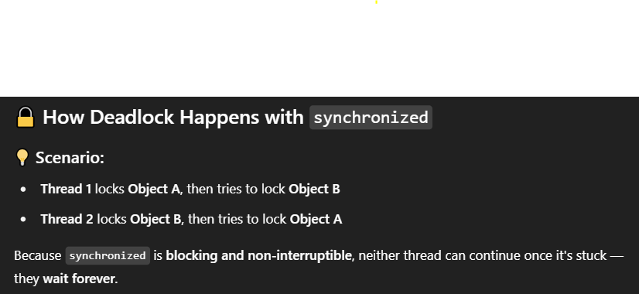

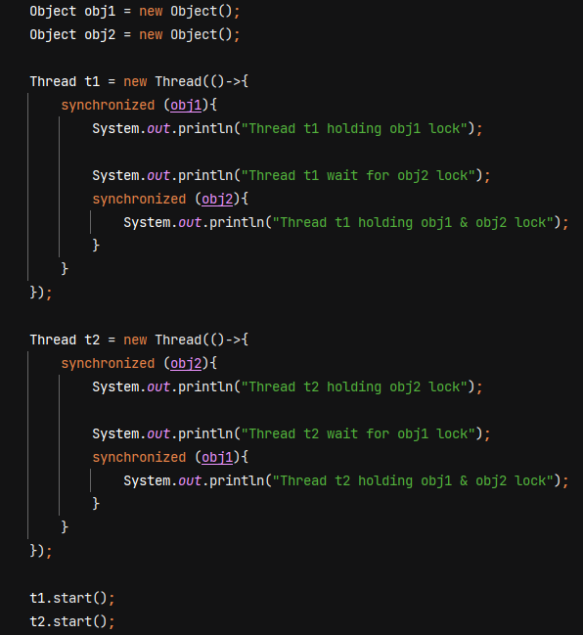

🡺 If a thread has acquired a lock, it can acquire the same lock again, without blocking.

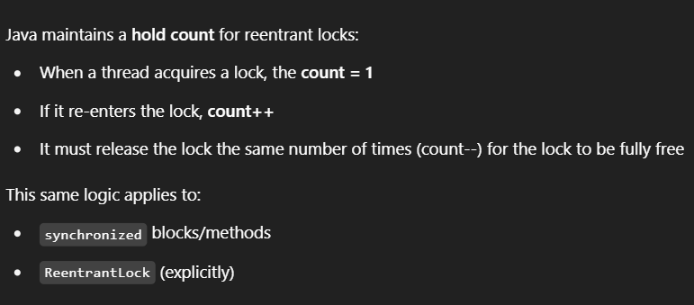

Java's intrinsic locks (used with synchronized) are also reentrant.

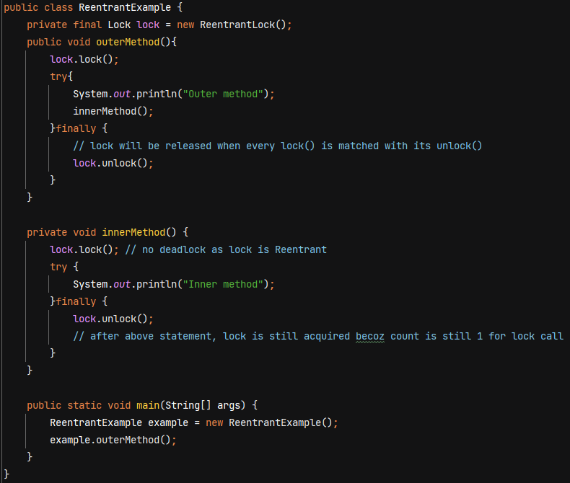

**Lock’s Fairness**

* **A fair lock ensures that threads acquire the lock in the order they requested it  
  (i.e., a first-come, first-served basis)**
* A thread will not starve (i.e., will not have to wait indefinitely) because threads that arrived earlier in the queue are guaranteed to get the lock before any new threads.
* A non-fair lock (when fairness is set to false) does not guarantee order
* By default, value is false.

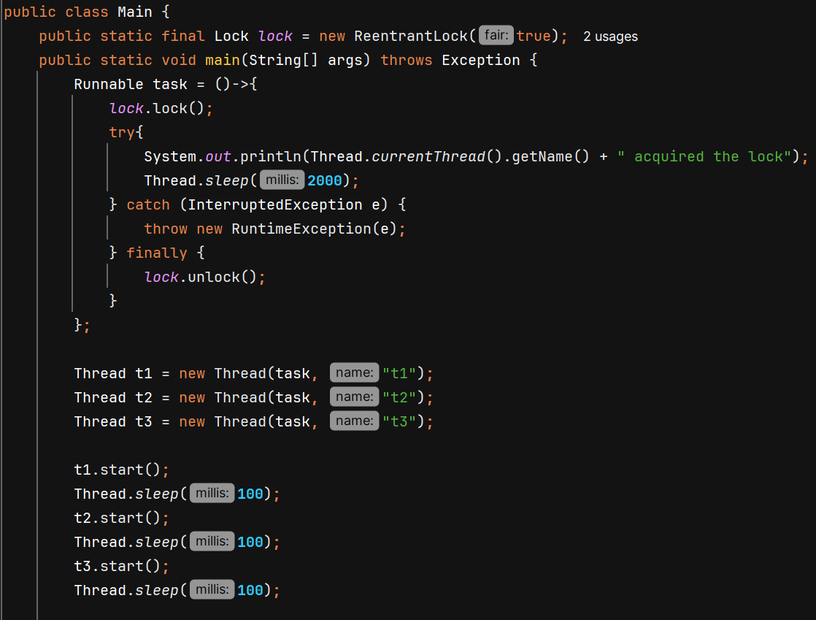

O/P 🡪 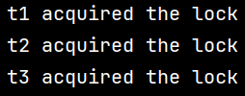

Problems with Synchronized –

* No fairness
* indefinitely blocking to acquire lock
* No Interruptibility
* No distinguish between read /write operations – synchronized will block every thread.

**ReadWriteLock** – it allows multiple threads to read resources concurrently (shared lock) as long as no thread is writing to it. It ensures exclusive access to write operation. (exclusive lock)

* **Multiple Readers** can hold the read lock
* **Only 1 Writer** can hold the write lock
* No Reader can hold the read lock while a Writer holds the write lock
* If any Reader currently holds a read lock, a Writer thread cannot acquire the write lock until all Readers release the lock

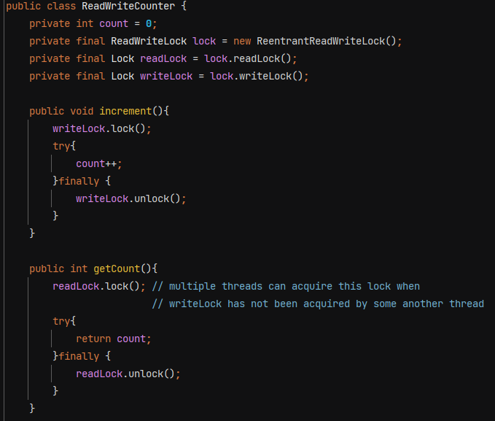

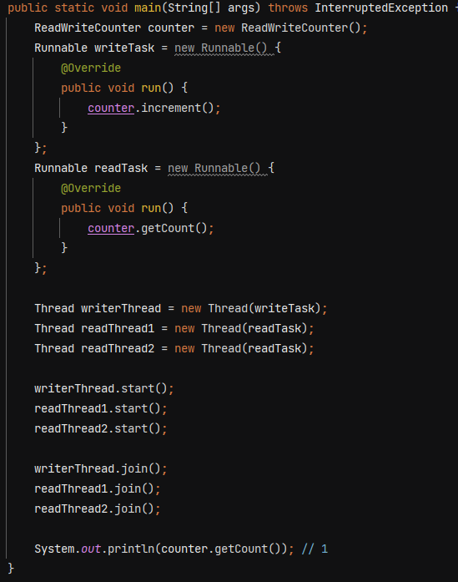

If no of read is very high compared to write, then ReadWriteLock is a better solution.

**Types of Locks –**

**1. Pessimistic Locking** – **assumes that concurrent conflicts are likely**, so it **prevents them upfront** by locking the resource before access.

Ex- synchronized, ReentrantLock, ReadWriteLock in Java

Database uses **SELECT FOR UPDATE** statement within a transaction to lock the rows returned by the SELECT query. This prevents other transactions from modifying those specific rows until the current transaction is committed or rolled back, ensuring data consistency in concurrent environments.

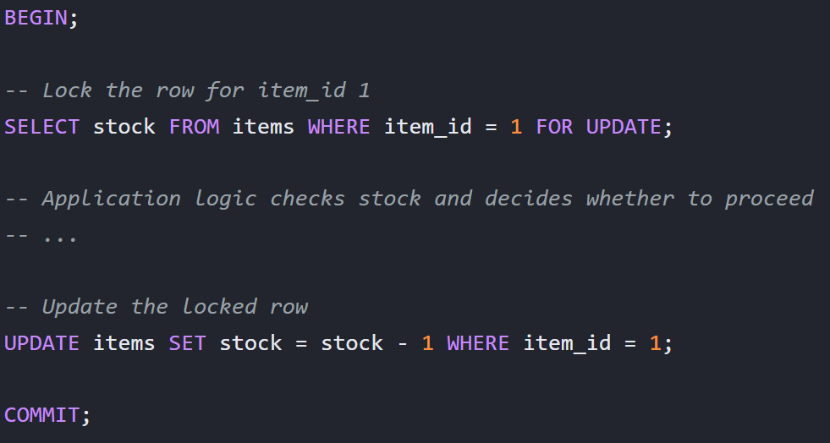

**2. Optimistic Locking** – **assumes conflicts are rare**, so it **does not lock upfront**. Instead, it **detects conflicts at commit time** and retries if needed.

It works by saving a **version/state** and validating it during update –

* Read data without locking and remember the version
* Update data only if the version is unchanged
* If update success 🡪 increment the version
* If update fails 🡪 rollback & retry all steps

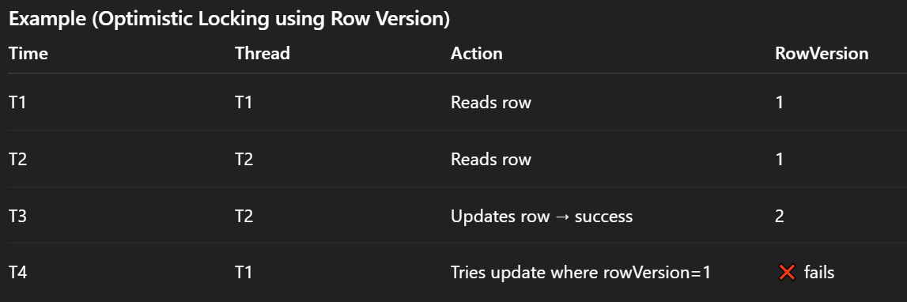

Spring Data JPA befault uses optimistic locking. It is activated only if your entity has version field –

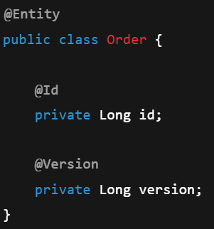 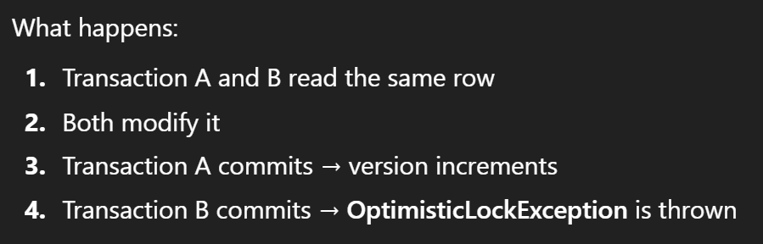

**StampedLock –** is a high-performance read–write lock that supports:

* Write lock (exclusive)
* Read lock (shared)
* Optimistic read (lock-free read)

A Stamp is a long value representing the lock’s state at the time it was obtained. 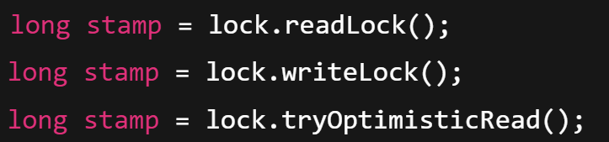

**lock.validate(stamp)** returns false if a **write lock** was acquired after the stamp was issued; otherwise it returns true.

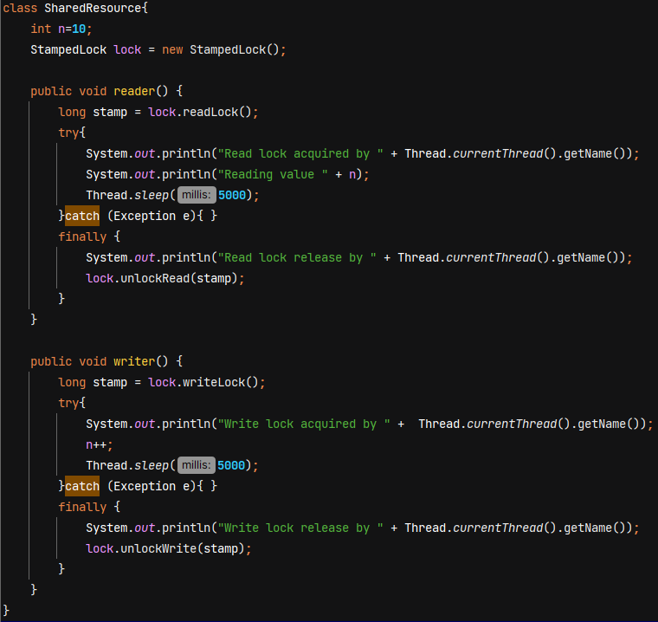

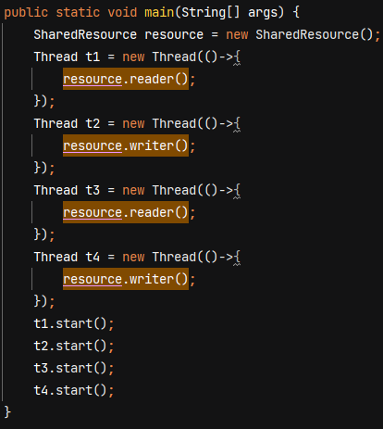 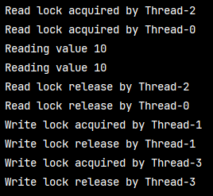

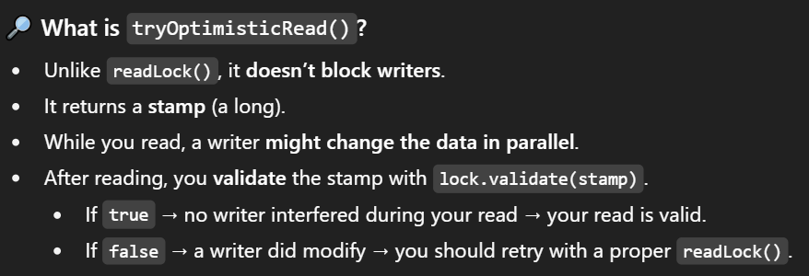

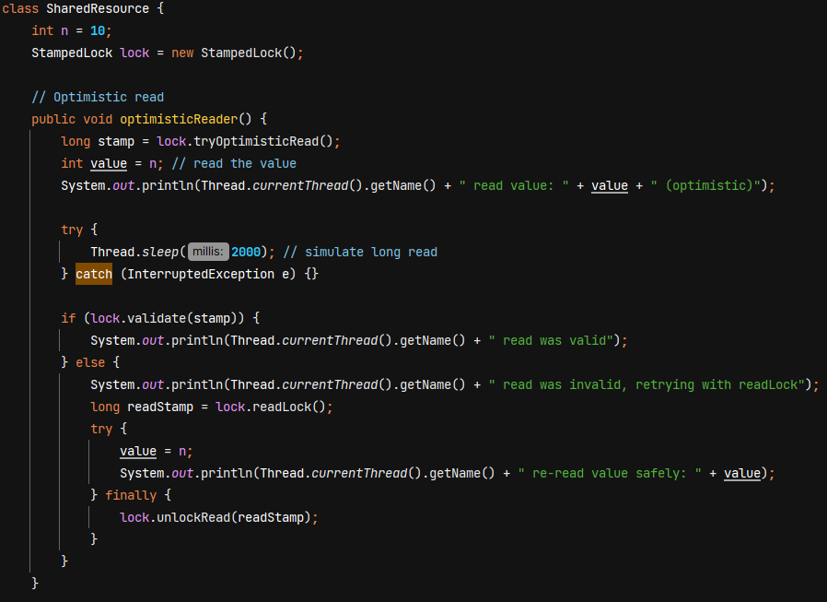

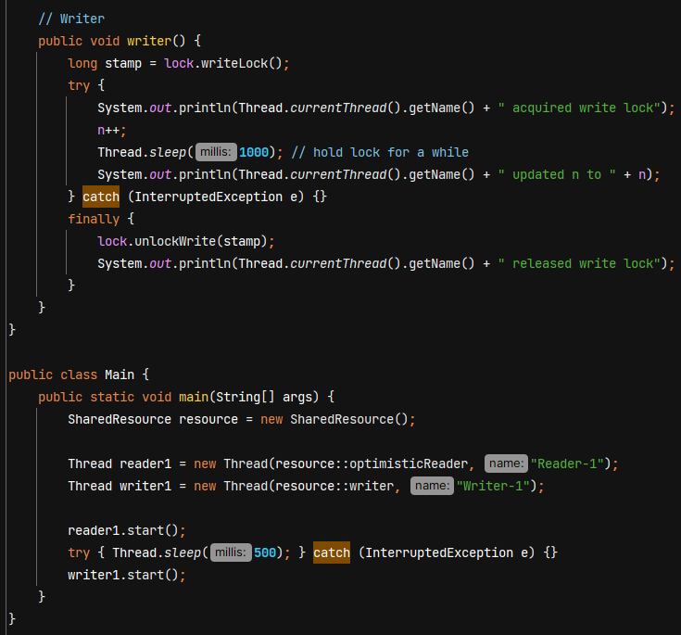

O/P - 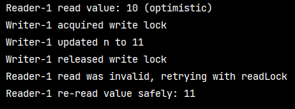

tryOptimisticRead() is better than readLock() when writes are rare and reads are extremely frequent as **it avoid locking overhead**.

**Semaphore** – It *is a synchronization tool that controls how many threads can access a shared resource at the same time. Unlike a lock (which allows only one thread), a semaphore can allow multiple threads, depending on the number of permits given in its constructor.*



Ex- If an office has **2 printers**, only **2 people** can print simultaneously. Semaphore with 2 permits is used to control access. The 3rd person who tries to print waits until one printer is free.

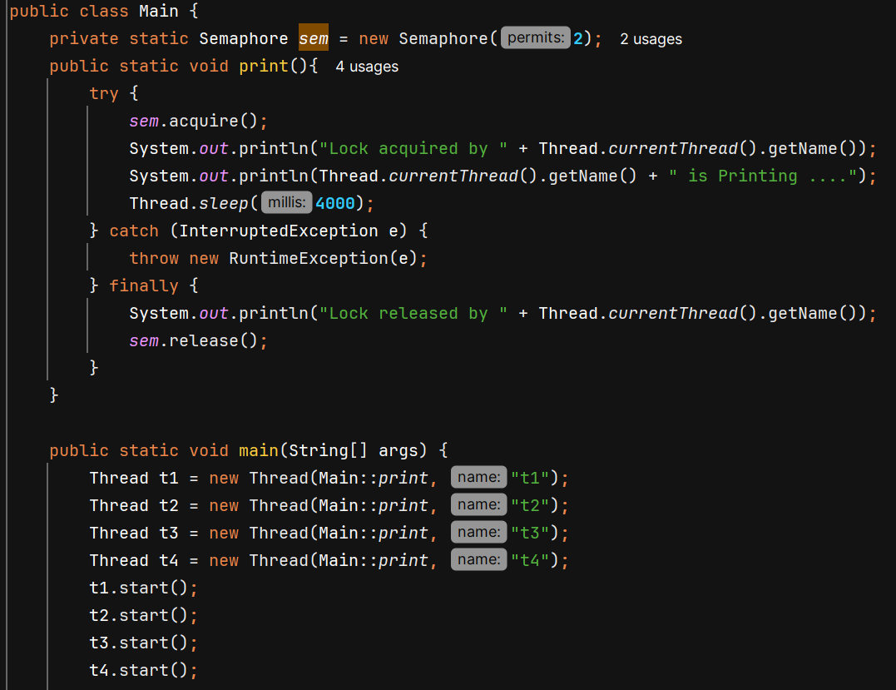 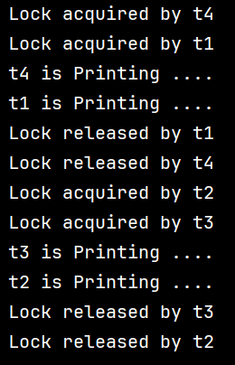

**Thread Communication**

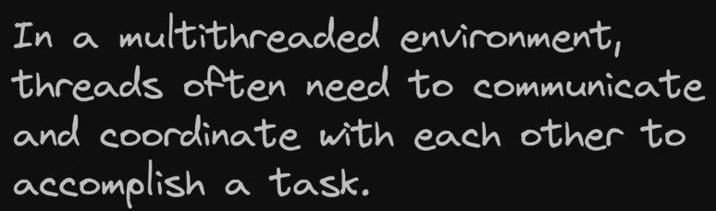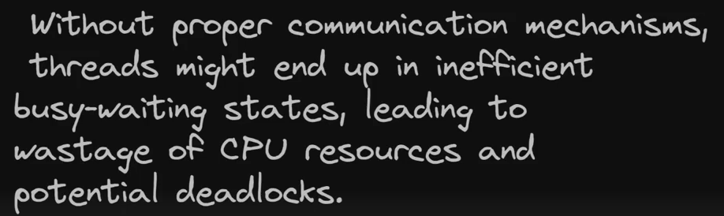

For thread communication, we have methods like wait(), notify() and notifyAll(). These methods belong to the **Object class**, not Thread.

**Wait()** 🡪 tells current thread to release the lock and wait until some other thread run notify() or notifyAll()

**Notify()** 🡪 wakes up a single thread that is waiting

**NofityAll()** 🡪 wakes up all threads that are waiting

These methods **can only be called on an object when the current thread holds the object’s *monitor lock***. That means **they work with synchronized**, not with explicit locks like ReentrantLock.

Ex- 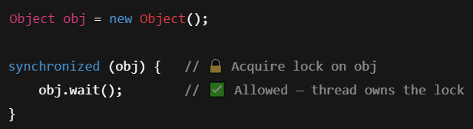

When notify()/notifyAll() is called, the waiting thread is **moved from the waiting state to the blocked state**, but it **cannot proceed until it re-acquires the same monitor lock**, which only happens **after the notifying thread exits the synchronized block**.

Ex- We want Producer to produce data but wait if hasData is true. And Consumer should consume data when hasData is true.

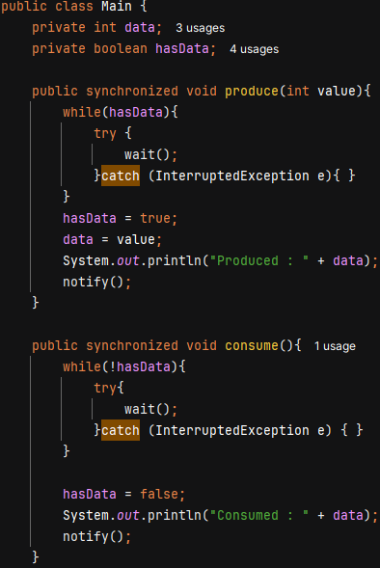 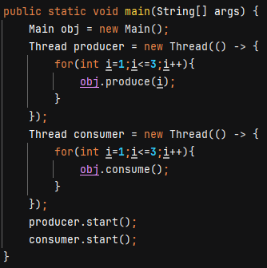 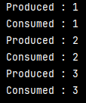

Ex- Producer Consumer problem using Queue –

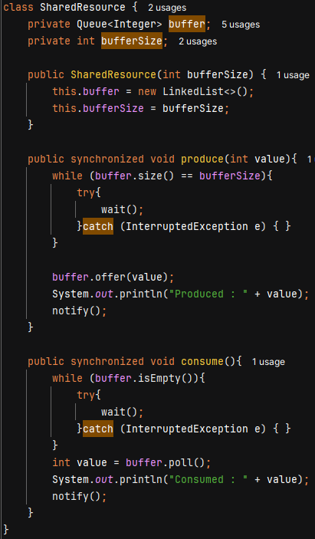 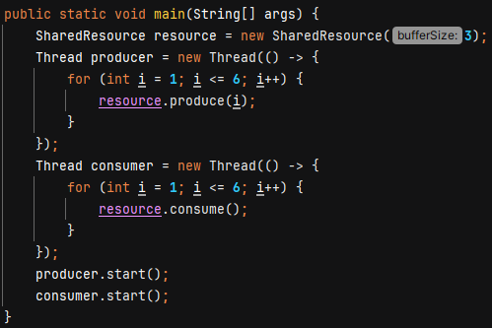 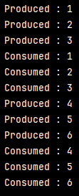

**Thread Communication in ReentrantLock/ ReadWriteLock –**

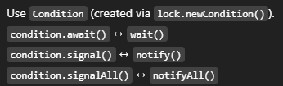A thread that is blocked in await() / wait() can be interrupted and wait() / await() will immediately throw InterruptedException

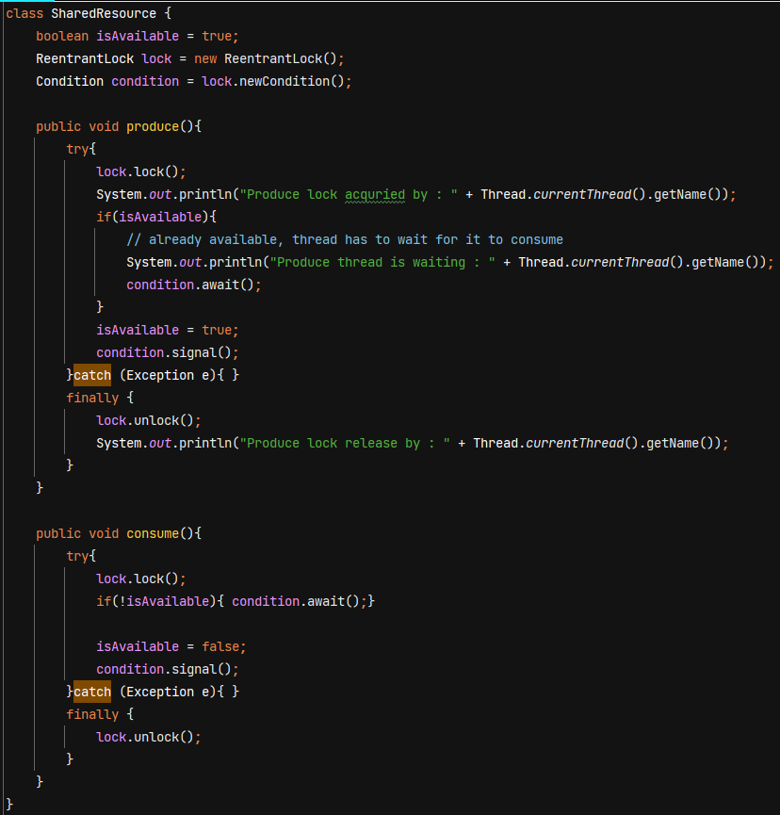

**Thread Safety** – a code is thread safe if it gaurantees no race condition when multiple threads try to access the critical section.

**Lambda Expression** – anonymous function 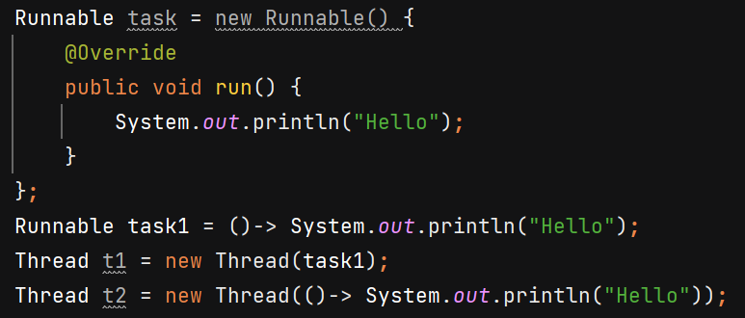

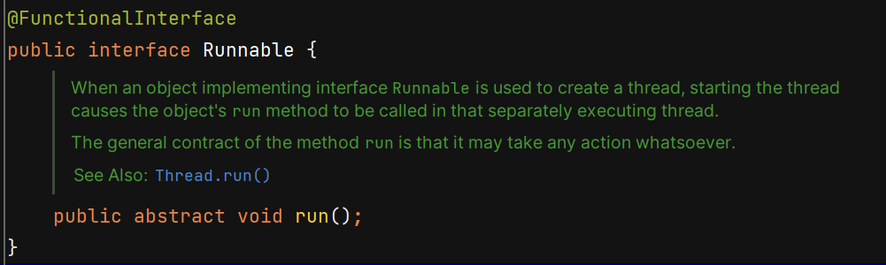

Suppose an API is having load of 100 hits per second -

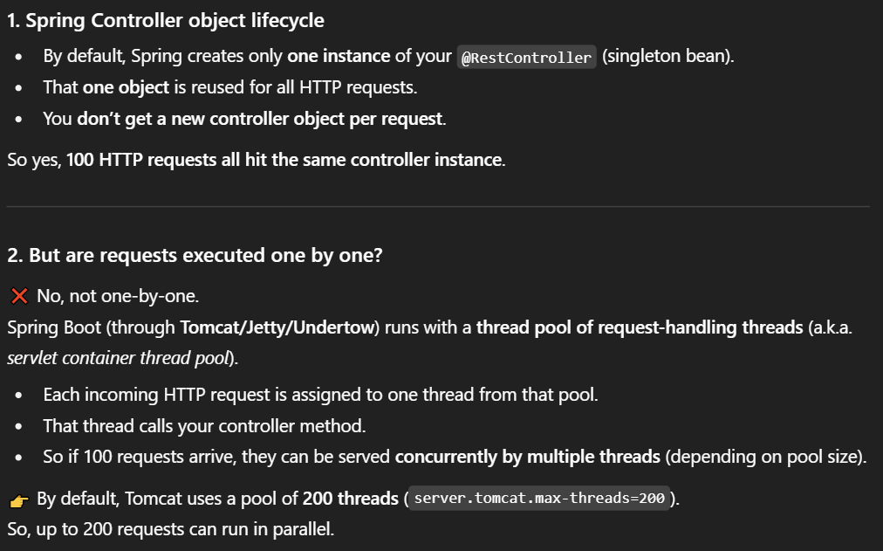

A servlet container is a runtime environment for Java servlets.

* Acts like a webserver for Java apps.
* Manages : HTTP requests & responses, Servlet lifecycle, Threads & Concurrency, Sessions & Security. Ex- Apache Tomcat, Jetty

A servlet has a well-defined lifecycle managed by the container: init() → service() → destroy()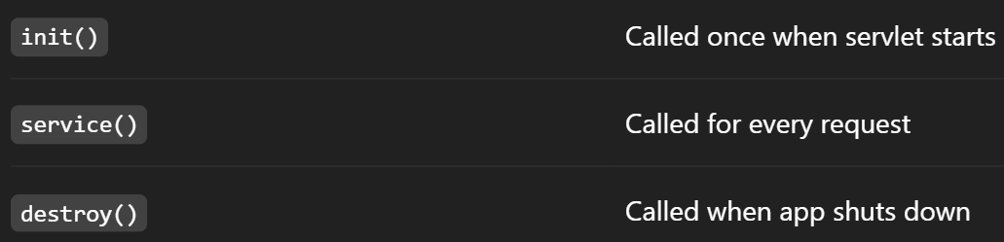

<https://hackernoon.com/multi-threading-in-spring-boot-with-executorservice-and-completablefuture>  
  
<https://medium.com/@nidhiupreti99/introduction-to-multithreading-java-spring-boot-b4930b73f302>

**Thread Pool** – It’s a collection of reusable worker threads that are ready to perform a task concurrently.

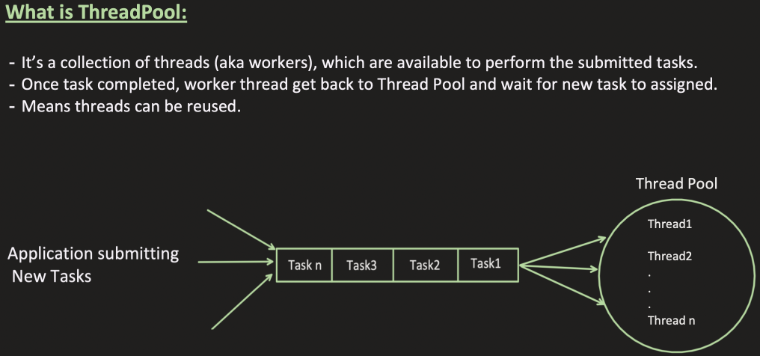

1. **Thread creation time can be saved** – Thread creation takes time because certain memory allocation needs to be done. With thread pool this can be avoided by reusing threads.
2. **Control over thread count** – puts a limit on no of threads that can be created.

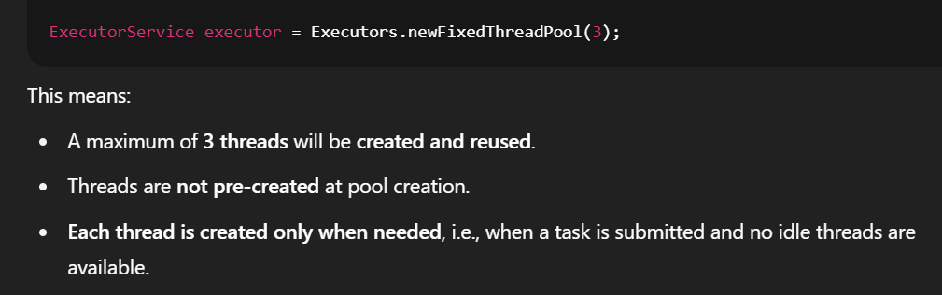

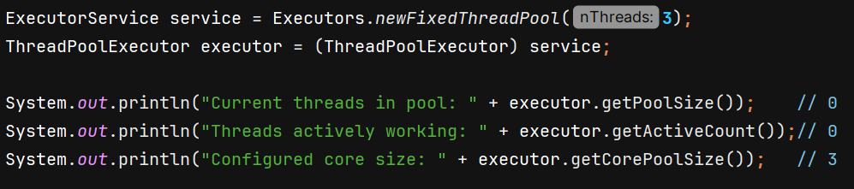

1. 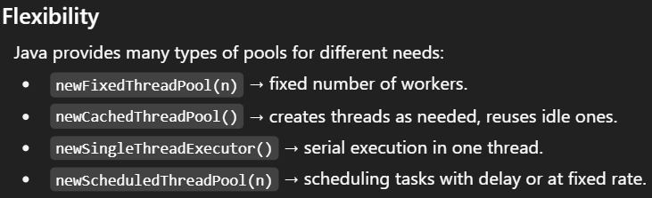
2. 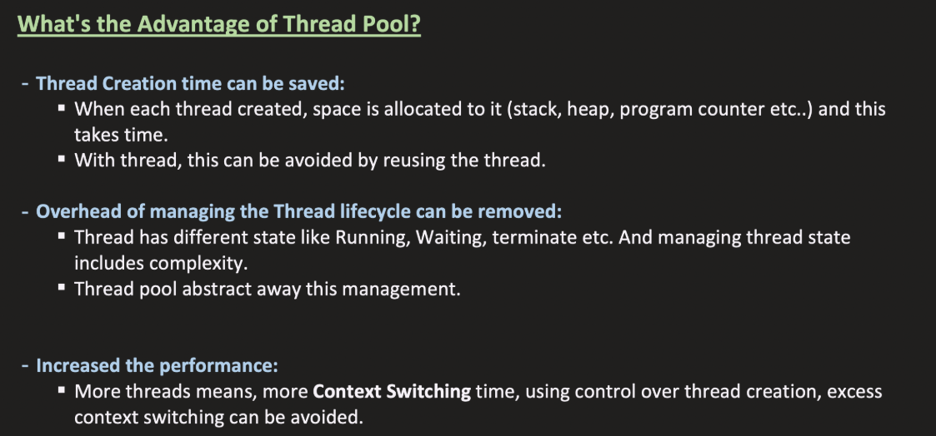

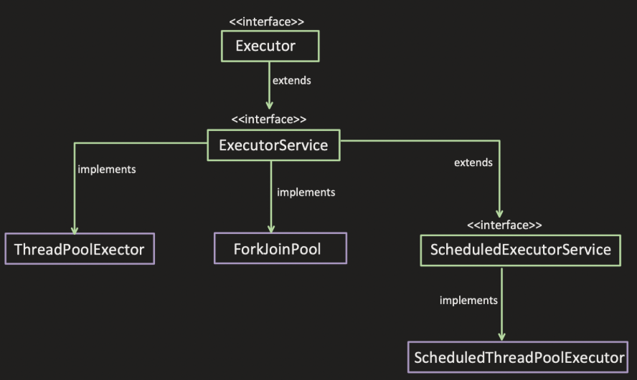

**ThreadPoolExecutor**

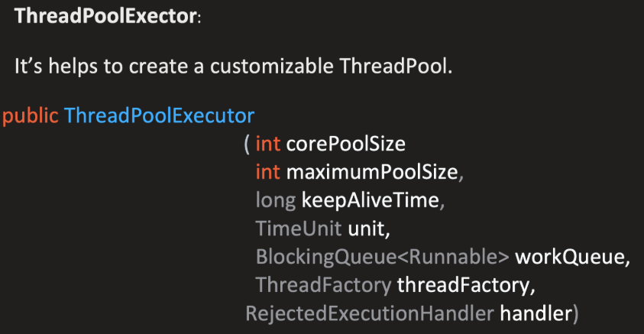

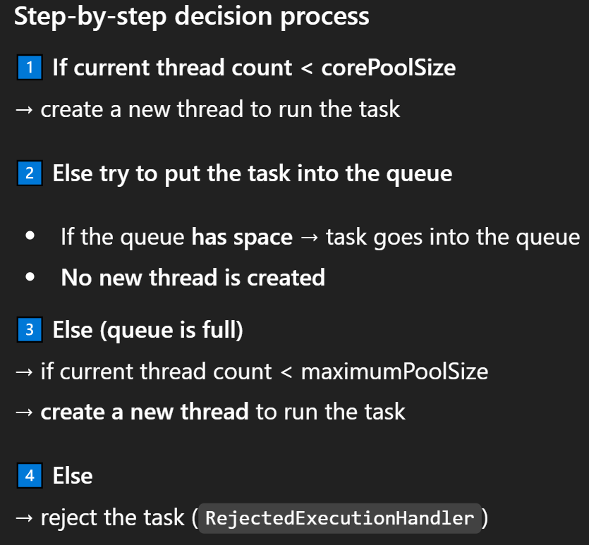 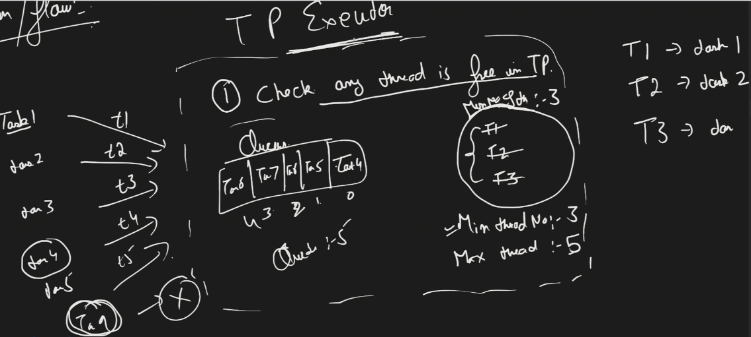

Suppose Thread 1, 2, 3 are running Task 1, 2, 3 and Task 4, 5, 6, 7, 8 are in Queue.

Now if Task 9 comes, it will not find any free thread in TP and also no any space in queue, then ThreadPoolExecutor will see that poolSize 3 < maxPoolSize 5 🡪 so create 1 more thread T4 which will be assigned Task 9.

If Task10 comes, then it will find no free thread in TP and queue is full but poolSize 4 < maxPoolSize 5 🡪 so T5 is created and assigned task10.

Now if Task11 comes the it will be rejected.

**corePoolSize :** minimum number of threads to keep in the pool, even if they are idle.

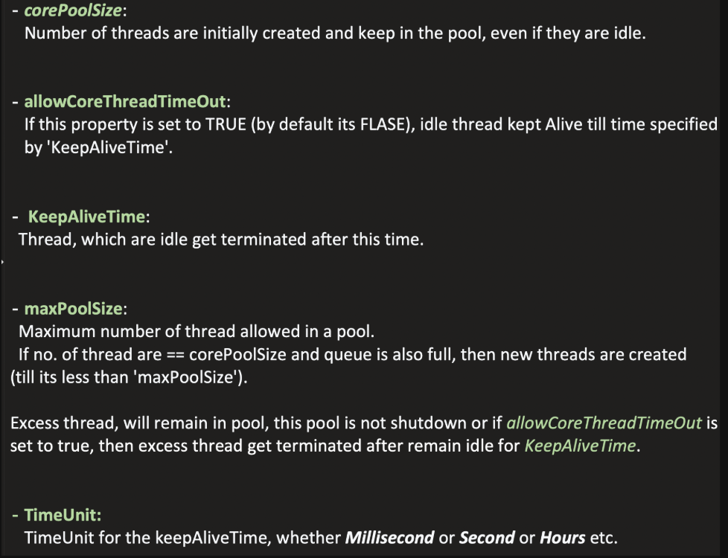

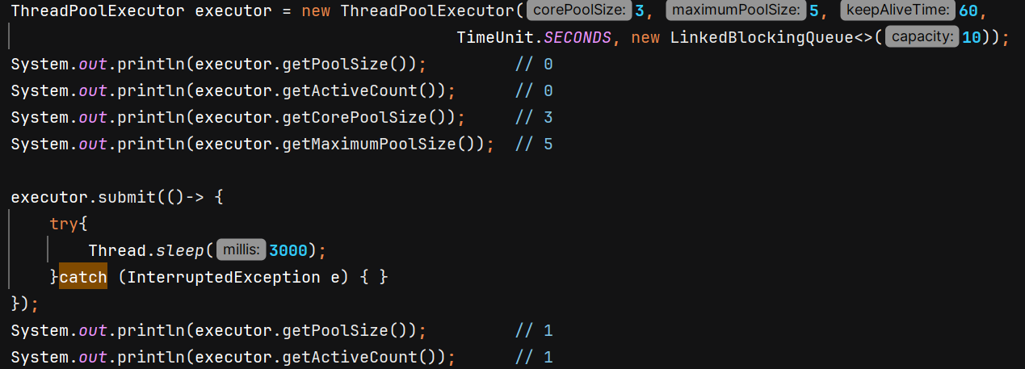

executor.**prestartAllCoreThreads**() **🡪** it will start all core threads causing them to idly wait for work

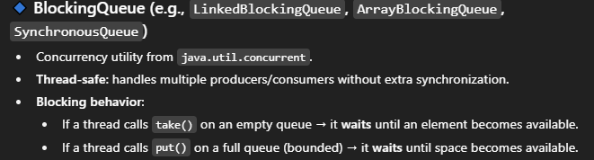

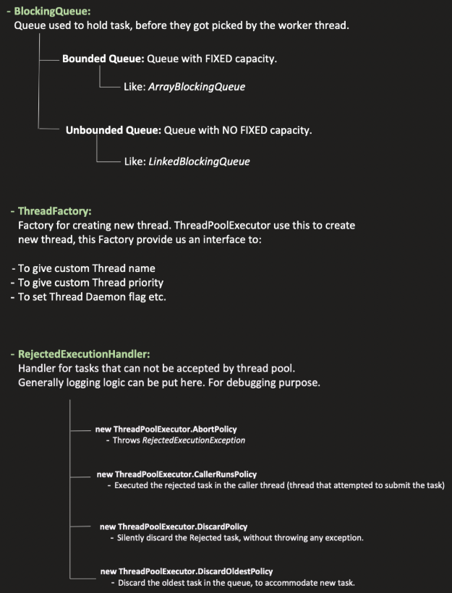

ThreadPoolExecutor will create threads on its own, give thread name, priority, thread daemon value on its own. But if you want to override that property you can provide ur own **ThreadFactory.**



Why we don’t create thousands of threads in java –

1. **Memory Cost per Thread** - Each thread gets its own **stack memory** (default ~1 MB on many JVMs). If you create 10,000 threads → that’s ~10 GB just for stacks! (before even doing real work).
2. OS uses **context switching** to give CPU time to threads. If you create large no of threads, then OS spends most of its time **switching threads** instead of doing real work so kill performance.
3. More threads = more chances they compete for: Locks & Shared data. This increases **blocking time** and reduces throughput.

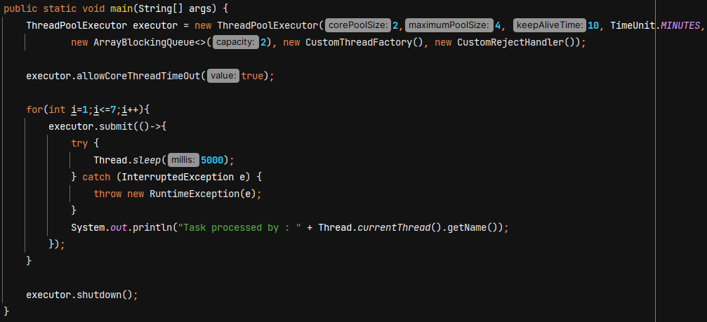

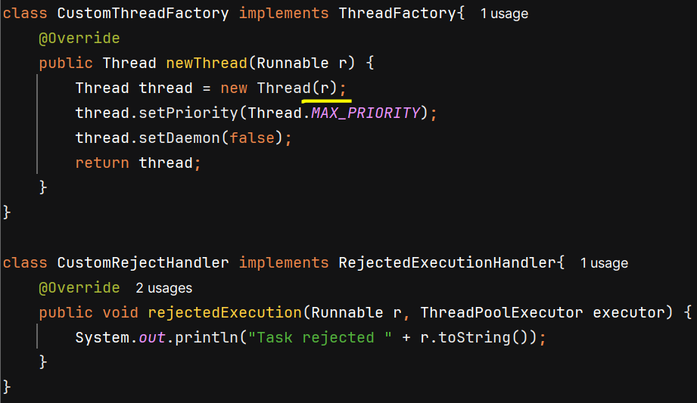

Using **Runtime.getRuntime().availableProcessors()** you can get the no of cores on your machine. If CPU has 64 cores then at the same time only 64 threads can execute concurrently.

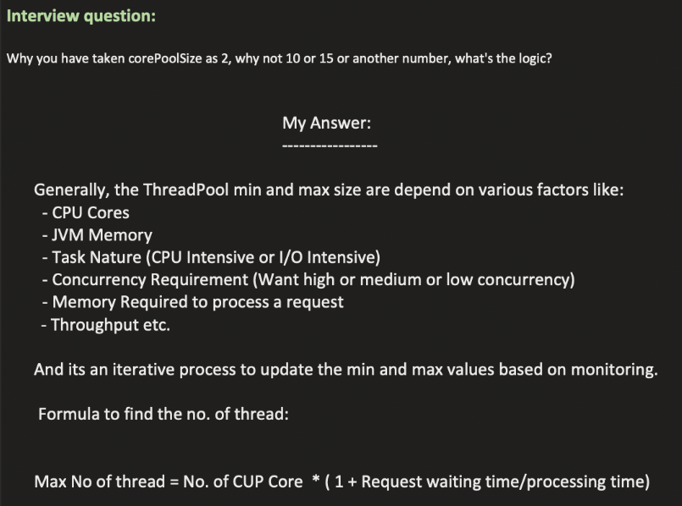

**CPU-bound task** means they want more CPU/processing time like image processing, encryption, ML tasks etc. **Less thread must be there.**

**I/O-bound tasks** spend most of their time waiting for I/O call or DB call to complete. During this waiting period, the thread is typically **blocked**, until the external resource responds. So its **better to have more threads** so CPU don’t wait, it can context switch and process some other thread.

Thread starvation in I/O bound threads – If you have a pool of 200 threads, and 199 are blocked waiting for slow database responses or external APIs, only 1 thread is available to handle a new incoming user request. New requests will pile up in a queue. If the queue fills up, the server might start rejecting connections, leading to severe performance issues.

**Throughput –** how fast you can process the request. (no of requests processed / second)

**Memory Required to process a request –** suppose there is a POST request which loads soo much data from DB, service calls into heap memory and heap also has limited space. Suppose if each request takes 10 MB and you created 100 threads to accept 100 requests concurrently so do u have sufficient memory in heap to process these requests?



The above formula basically consider CPU core, Task Nature and Throughput for giving no of threads.

For CPU intensive – request waiting time is very less (becoz they don’t wait for external resources) and processing time is more

For I/O intensive – request waiting time is more and processing time is less.

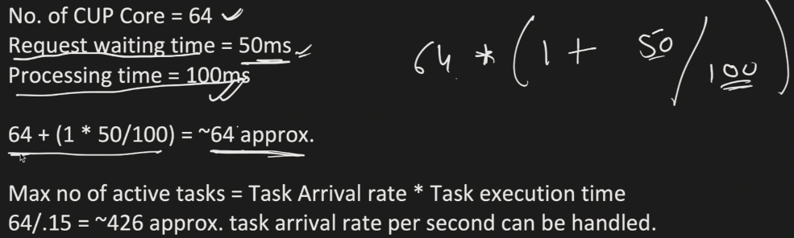

But this formula does not consider the memory -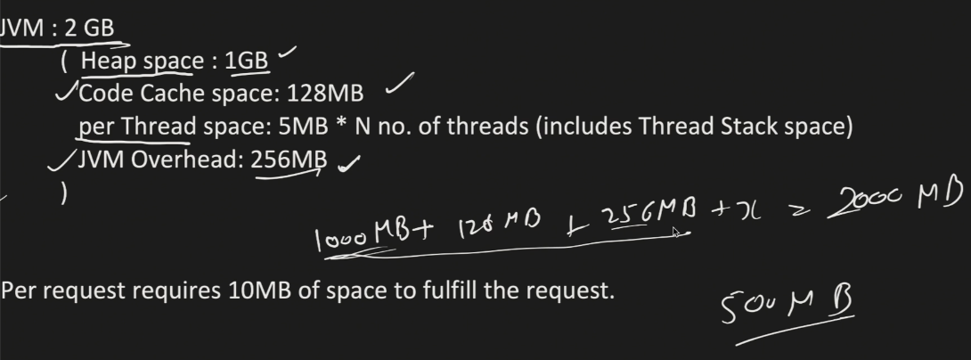

Out of this remaining 500MB we have to accommodate memory for Threads. For each thread we need to create stack, register, etc.

If 1 thread takes 5MB then we can create maximum 500/5 = 100 Threads

**Now consider Memory required to process a request –**

Suppose 1 requests takes 10MB becoz it has to load data from DB, from external calls and this data will be stores in Heap. If 100 Threads are created then 100 * 10 = 1000MB (~1GB) then this will full the heap that is risky again. So we can say lets put some buffer and use 60% or 70% of heap because we might need heap for some other tasks also.

So lets create 60 Threads. 60 * 10 = 600MB this much heap will be used by threads. Its safe number.

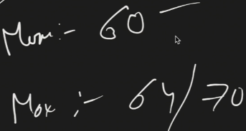 Now I have to monitoring, iterative load & performance testing and optimize this number.

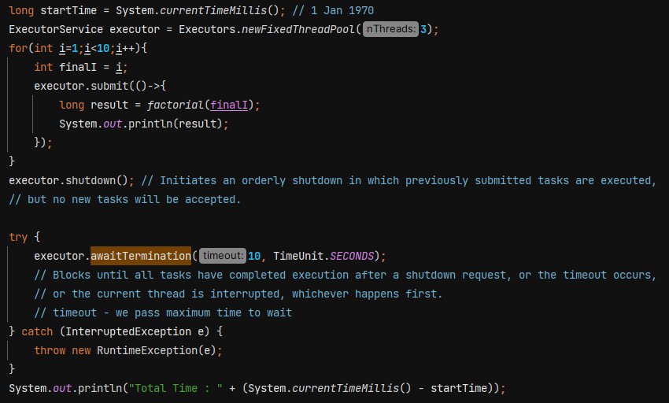

**submit()** 🡺 it accepts any number of tasks. The task is queued and will execute automatically if a thread from the pool is available.

**shutdown()** 🡺 Gracefully shut down the executor service. It does not block the current thread.

**shutdownNow()** 🡺 Forcefully terminates all running/waiting tasks immediately.

**awaitTermination()** 🡺 Blocks current thread and Returns true if this executor terminated and false if the timeout elapsed before termination. It is called after shutdown() ExecutorService.

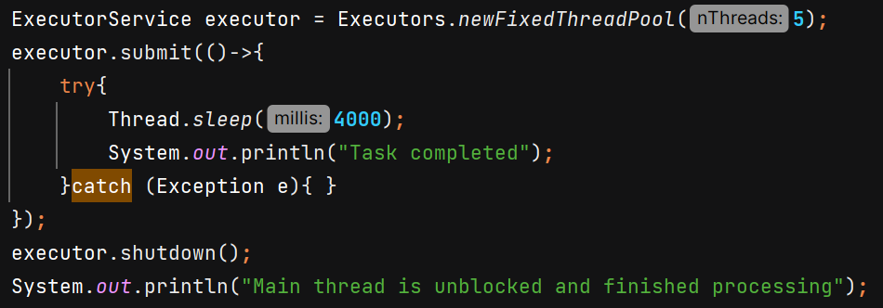

O/P - 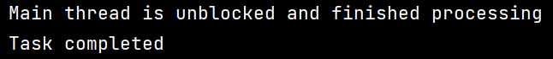



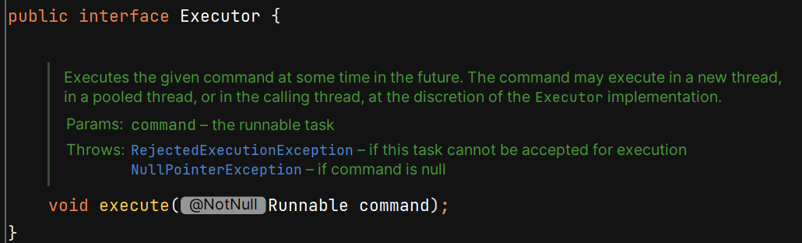

Executor does not contain methods like shutdown() so u need to manually do it. That’s why its useless. We’ll use ExecutorService becoz it provides more features.

**Submit()** 🡺 returns **Future<T>** which represents the result of an asynchronous task.

future**.get()** 🡺 blocks the current thread until task is completed, or current thread is interrupted.

We can also pass timeout like **future.get(5, TimeUnit.SECONDS)**

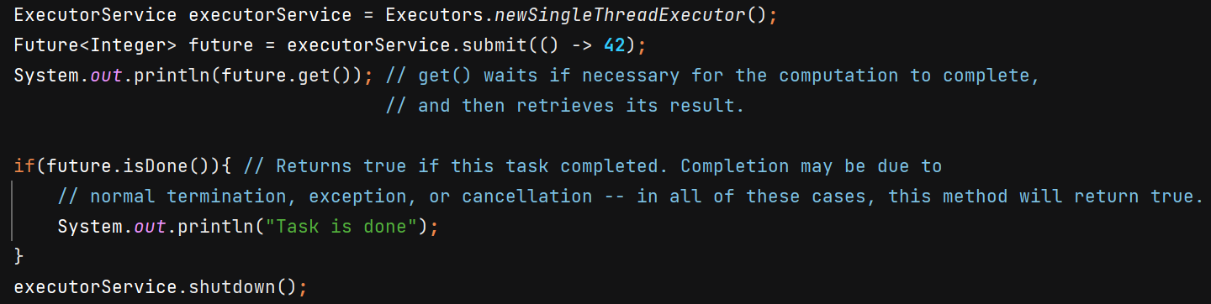

O/P - 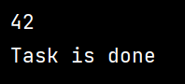

Submit() can take Runnable as well as Callable – 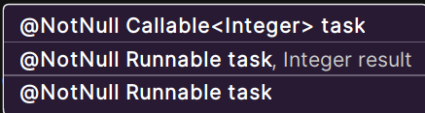

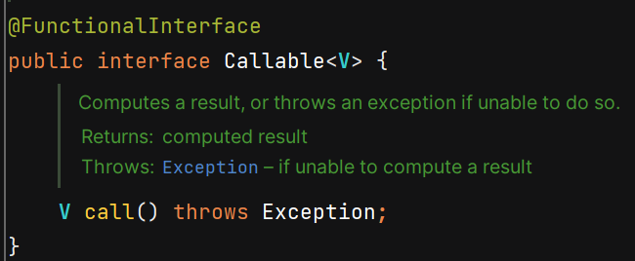 Callable returns value.

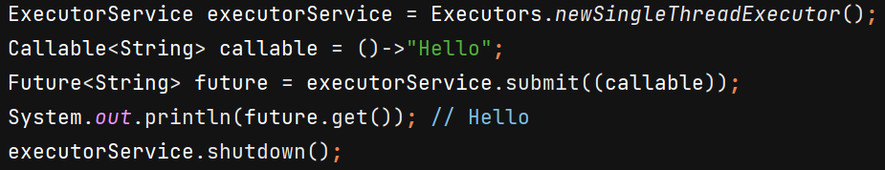

submit() method of Runnable argument is called -

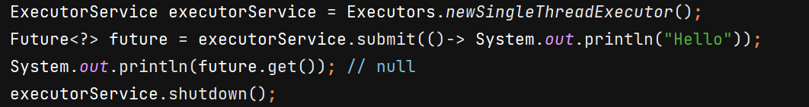

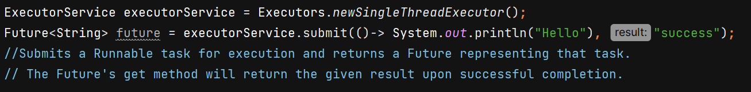

Difference - 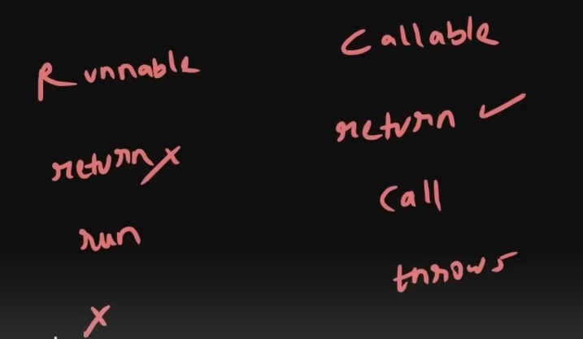

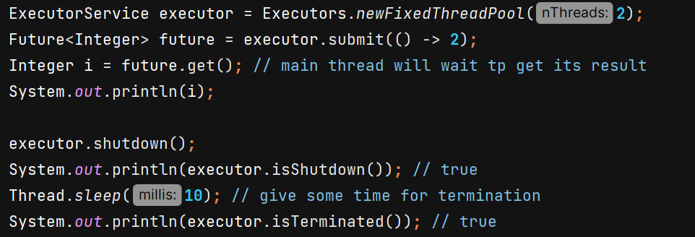

If tasks are **still running**, but shutdown() has already been called → isShutdown() returns true.

**isTerminated()** 🡺 return true if all tasks have completed after shut down

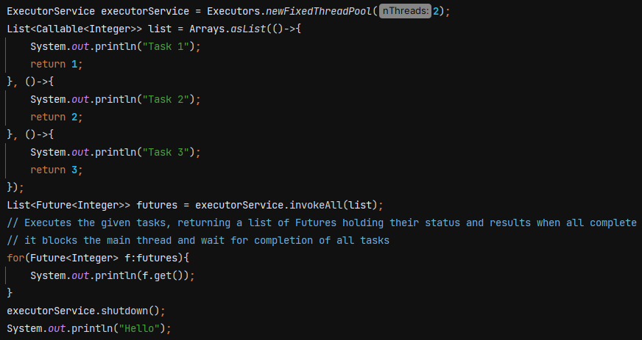 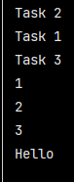

**invokeAll()** 🡺 It **submits all tasks** and then **waits (blocks)** until **all of them finish**.

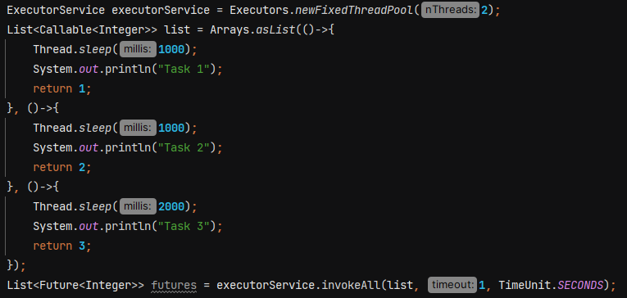 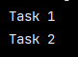

When we pass timeout in constructor, then it executes all the task which can be executed within time frame and other tasks are cancelled.

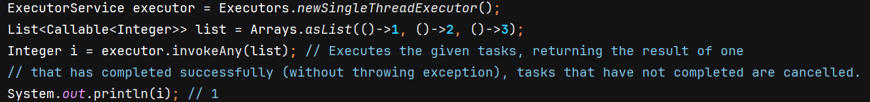

**invokeAny() also blocks the current thread.** We can also pass timeout just like invokeAll() and it will return TimeoutException if time elapse before any task successfully completes.

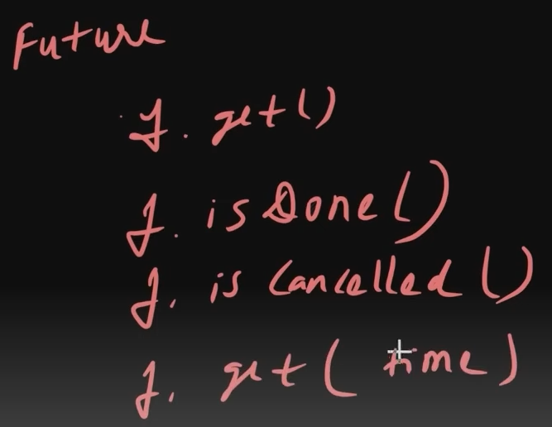

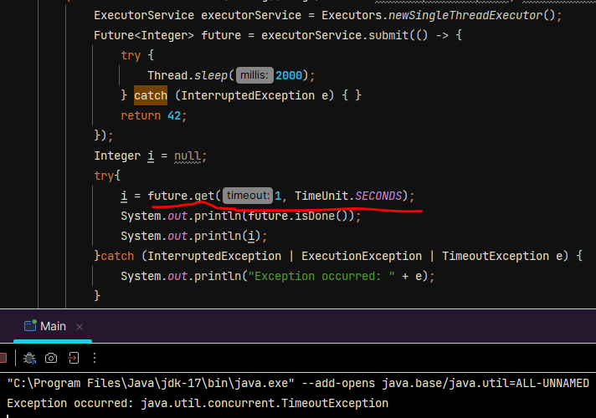

O/P 🡪 

Explaination :- It waits for 1 sec, if task get completed then fine otherwise it gives TimeoutException.

**isDone()** 🡺 Returns true if the task has completed. Completion may be due to normal termination, an exception, or cancellation.

**cancel(boolean)** 🡺 If the task has already completed it cannot be cancelled and .**cancel()** returns false.

* If task is still running it can be cancelled and **.cancel()** returns true.
* mayInterruptIfRunning parameter determines whether to run the complete task or not.
* Future will not return any value and we get **CancellationException** if we use **.get()**

**isCancelled()** 🡺 Returns true if this task was cancelled before it completed normally.

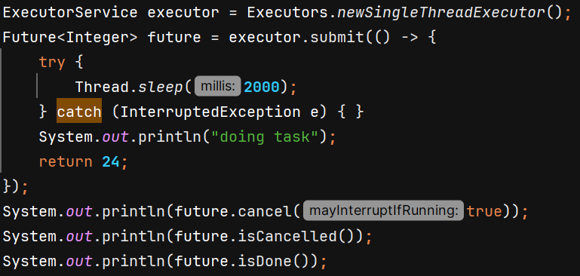 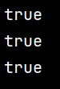

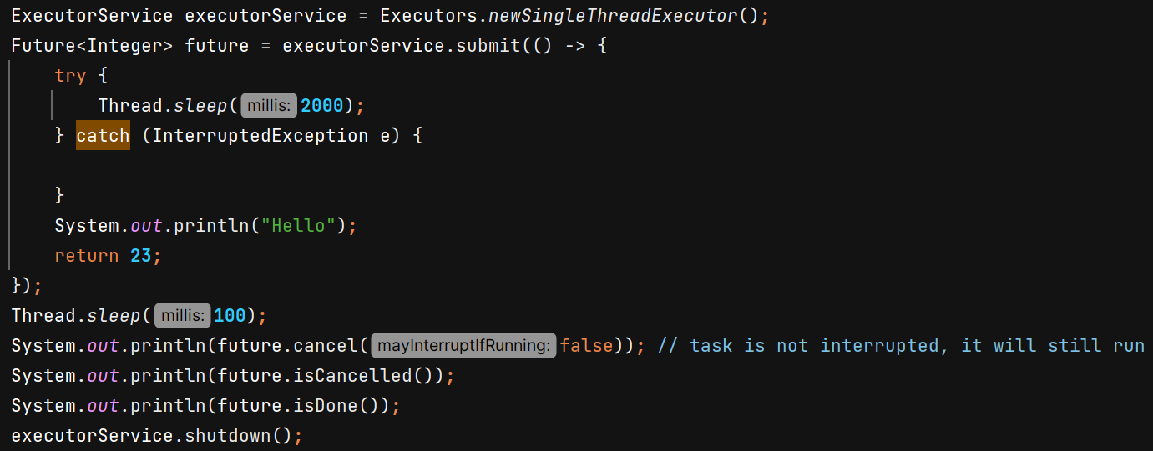 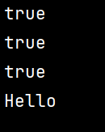

**Scheduled Executor Service** – used when we want something to run periodically. It helps to schedule tasks.





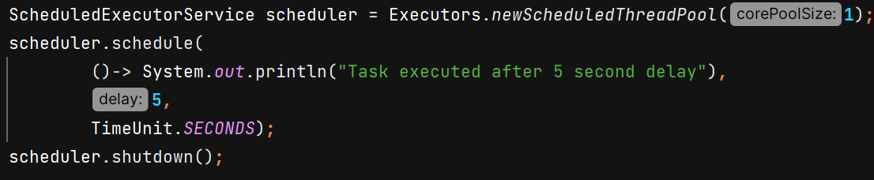

O/P 🡪 

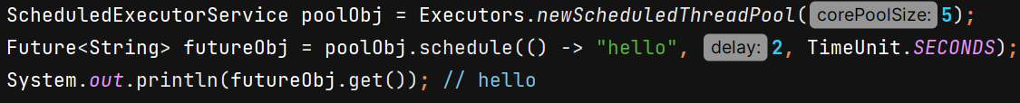

.**schedule() 🡪**  *Submits a one-shot task(runnable/callable) that becomes enabled after the given delay*

.**scheduleAtFixedRate()** 🡪 Submits a periodic task that becomes enabled first after the given initial delay, and subsequently with the given period; that is, executions will commence after initialDelay, then initialDelay + period, then initialDelay + 2 * period, and so on.

If scheduler.shutdown() is called **before the initial delay expires**, the scheduler will terminate immediately, and the task will never run. So we need to handle it properly –

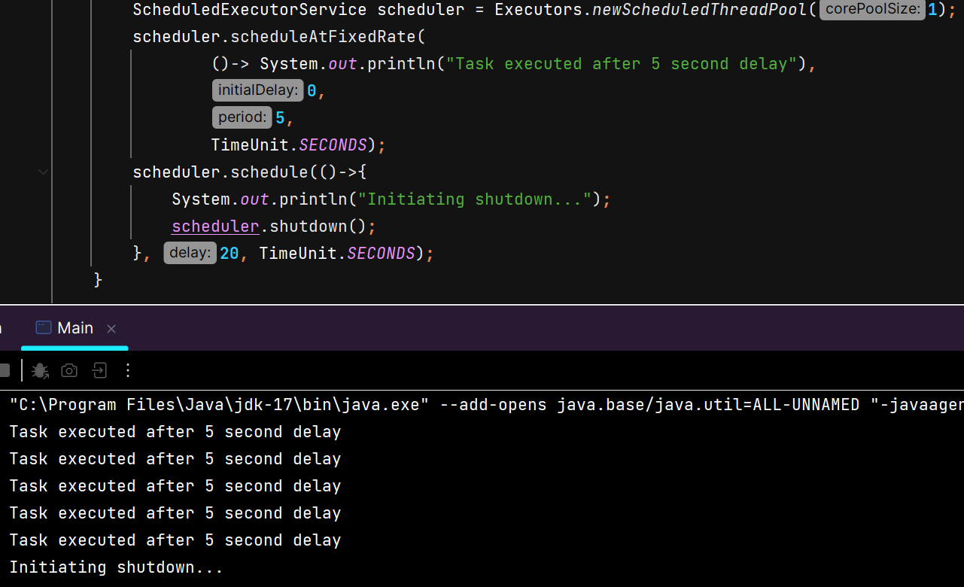

O/P 🡪 

**Note** – If previous task is slow and next task is scheduled, then it will wait in queue for completion of previous task and starts immediately after finish.

**scheduleWithFixedDelay()** 🡺 Submits a periodic action that becomes enabled first after the given initial delay, and subsequently with the given delay between the termination of one execution and the commencement of the next.

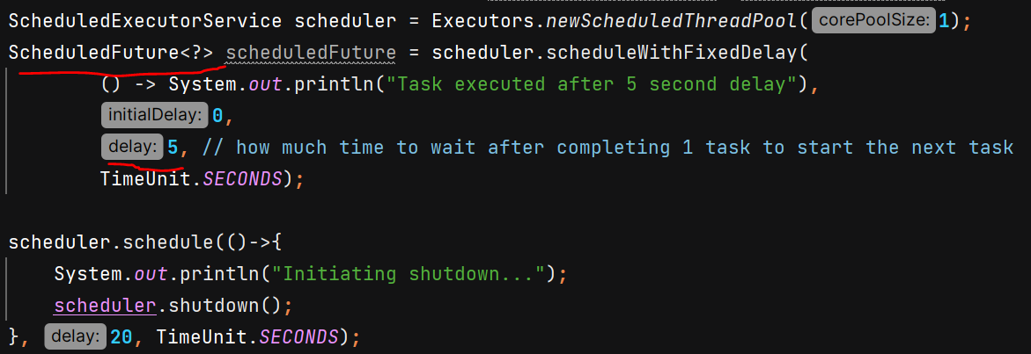

O/P 🡪 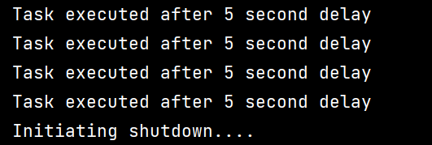

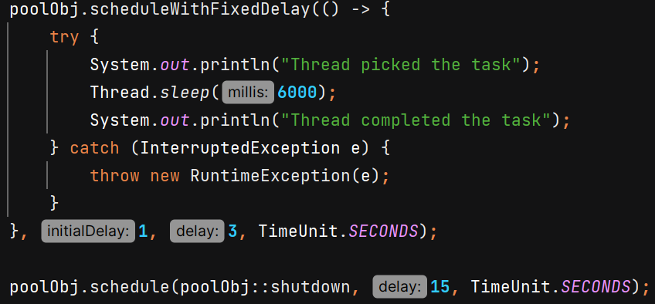 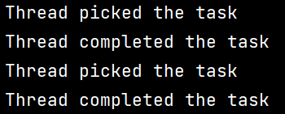

With fixed delay, after “Thread completed the task” next sout statement “Thread picked the task” comes after 3 seconds. **It wait for fixed delay before scheduling the next task.**

If I use at fixed rate, then after “Thread completed the task” next sout statement “Thread picked the task” will come immediately becoz task is already scheduled and waiting in queue for previous task to be finished.

**Cached Thread Pool –** It creates a thread pool where it creates new threads as per need and terminates them after 60 seconds of inactivity. It dynamically adjusts the pool size. It is useful when load is variable and short lived. Do not use it when task are very time consuming.



**CompletableFuture**

Introduced in JAVA 8 to handle asynchronous programming.

It **implements Future** interface so has all its method and provides additional capability like chaining.

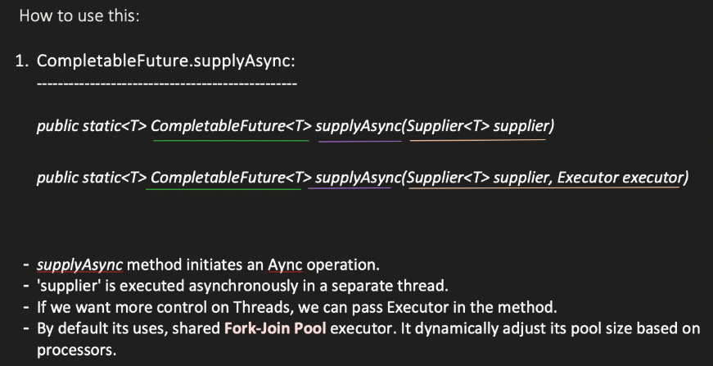

Default parallelism of ForkJoinPool.commonPool() = **max(1, availableProcessors − 1)**

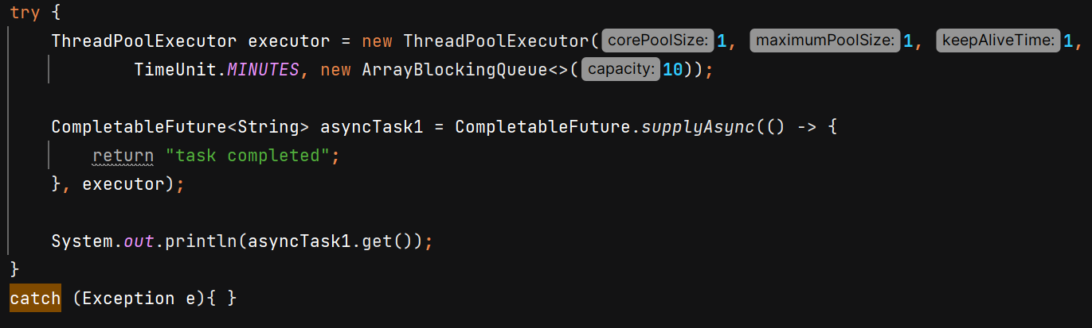

O/P - 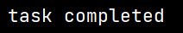

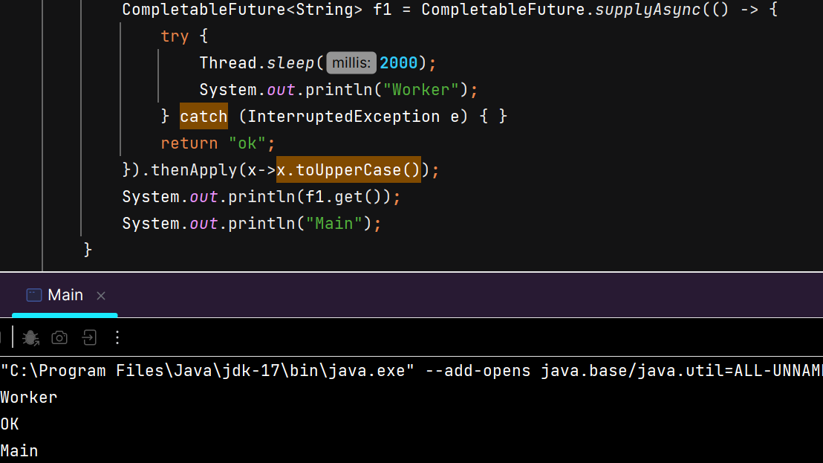 

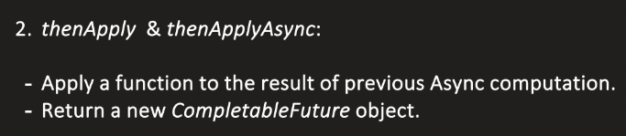 Takes Function as argument 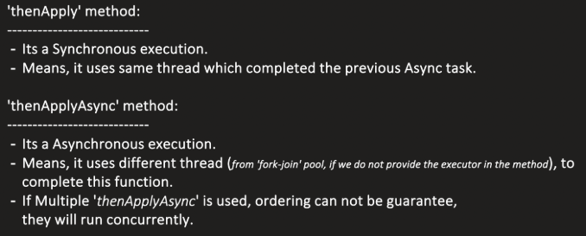

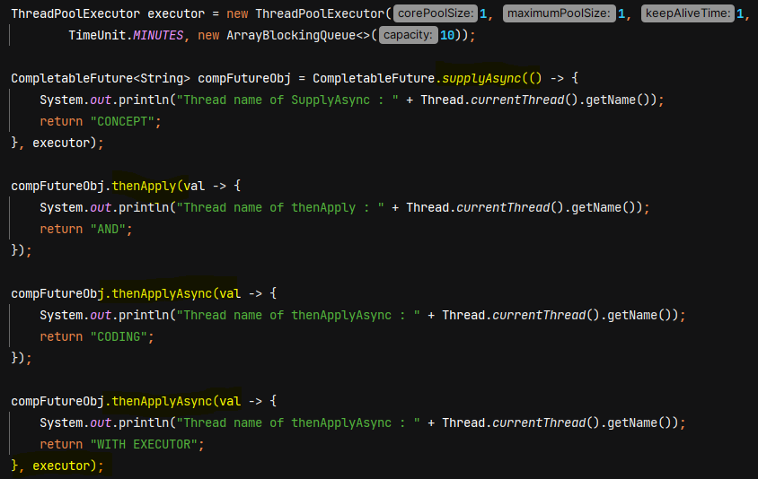

O/P - 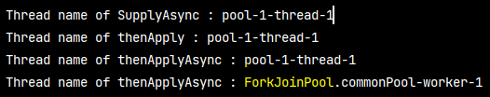

If we don’t provide executor in thenApplyAsync then ForkJoinPool.commonPool() will be used.

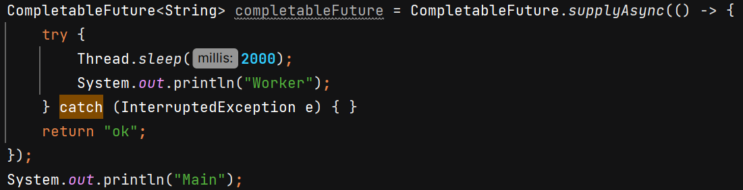 O/P – 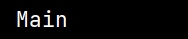

we don’t see sout of “Worker” because by default, CompletableFuture.supplyAsync() uses the **ForkJoinPool.commonPool()**, and the threads in this pool are **daemon threads**.

If we want to run the task –

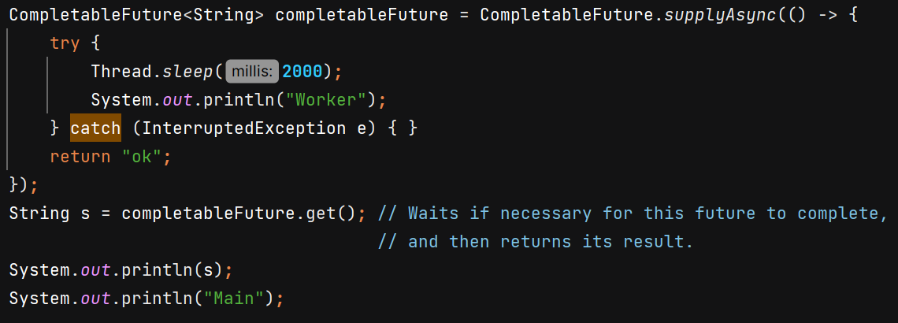 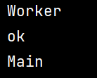

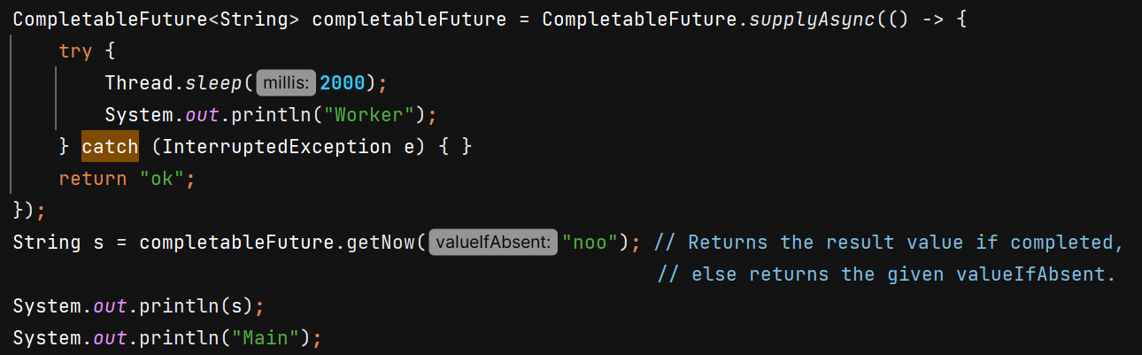 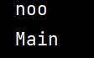

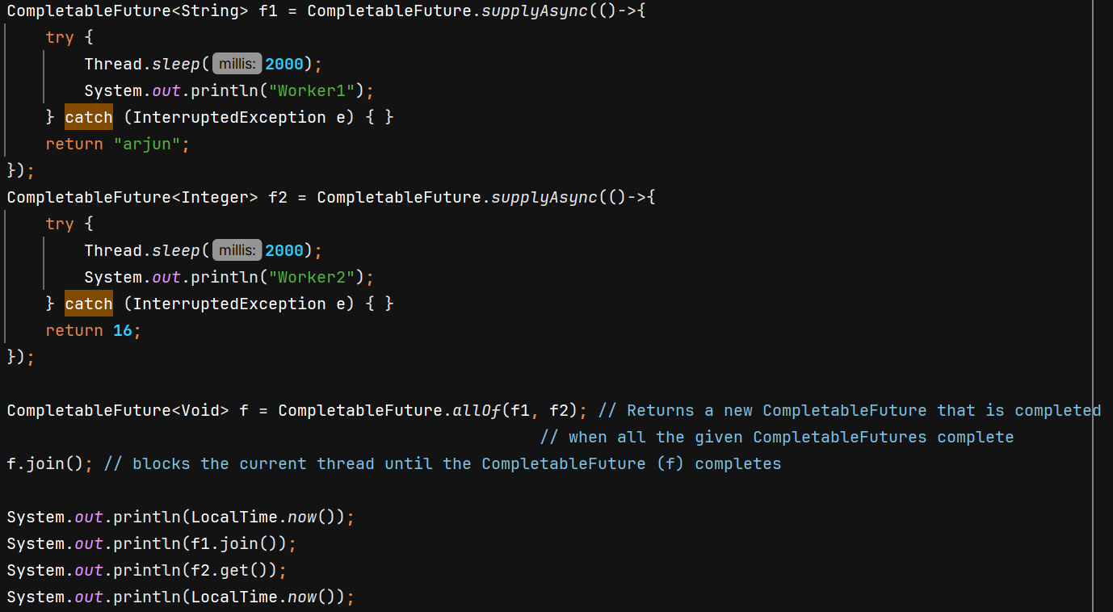 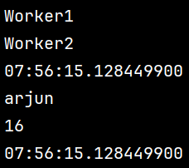

We can also use join() with CompletableFuture instead of get().

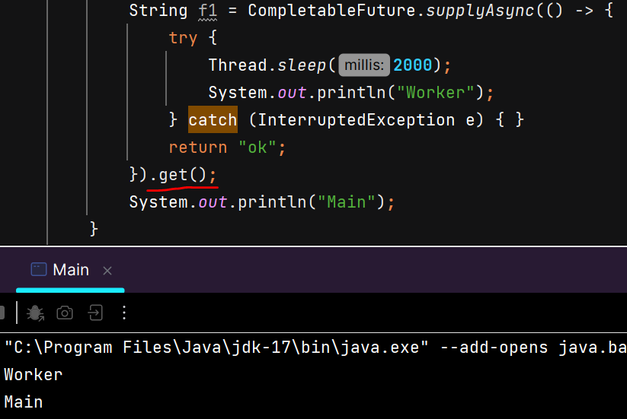 

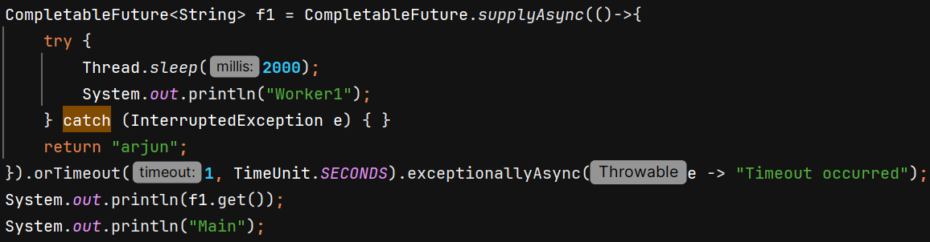 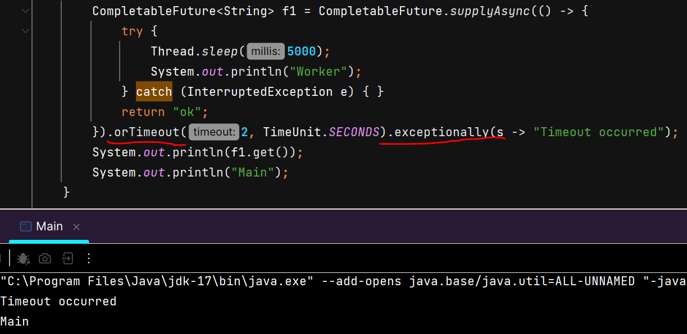

**Note**: Use CompletableFuture without a custom executor only for CPU-bound work.  
For any I/O-bound or blocking operation (HTTP calls, DB queries, file I/O), always provide a custom thread pool executor.

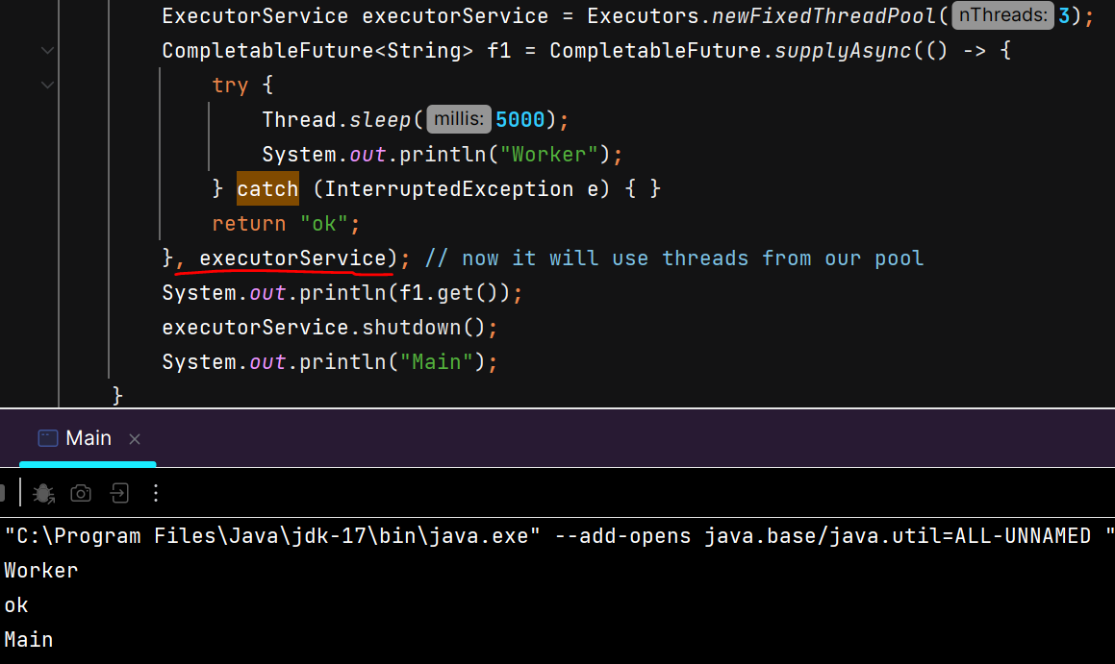 

shutdown() is necessary when using custom executor.

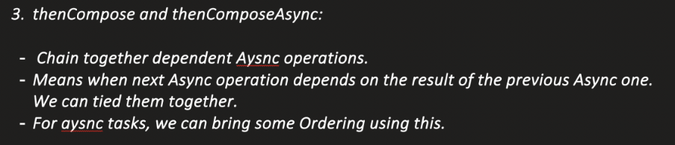

Takes Function as argument which returns CompletableFuture

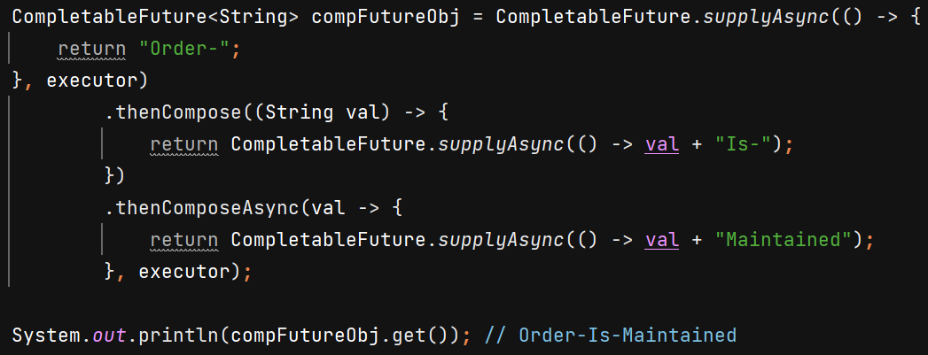

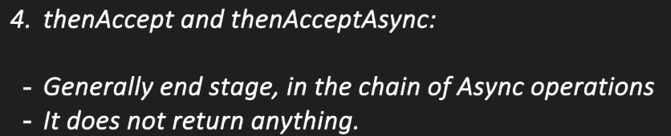Takes Consumer as argument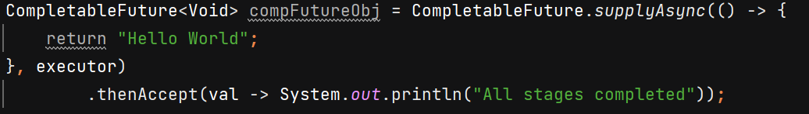 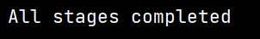

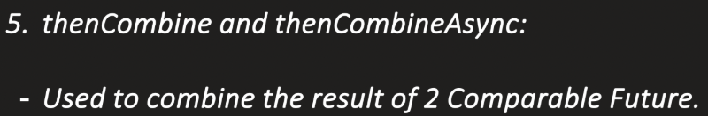 Takes BiFunction as argument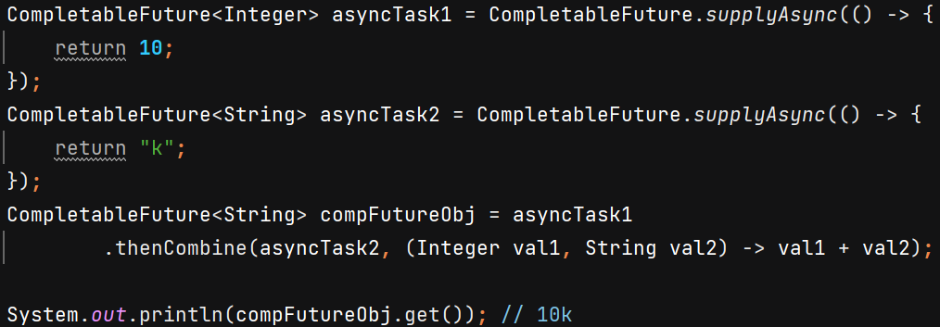

**6) runAsync()** – used when we pass runnable and no result needs to be returned 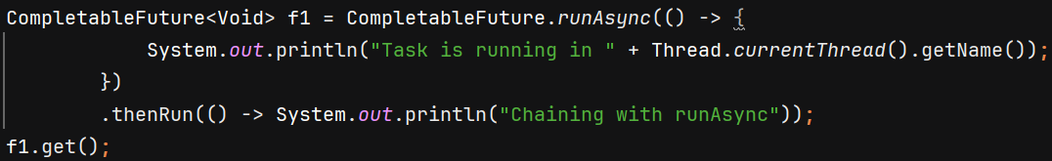

**Executors** is Utility class which provides methods to create Thread Pool Executor.

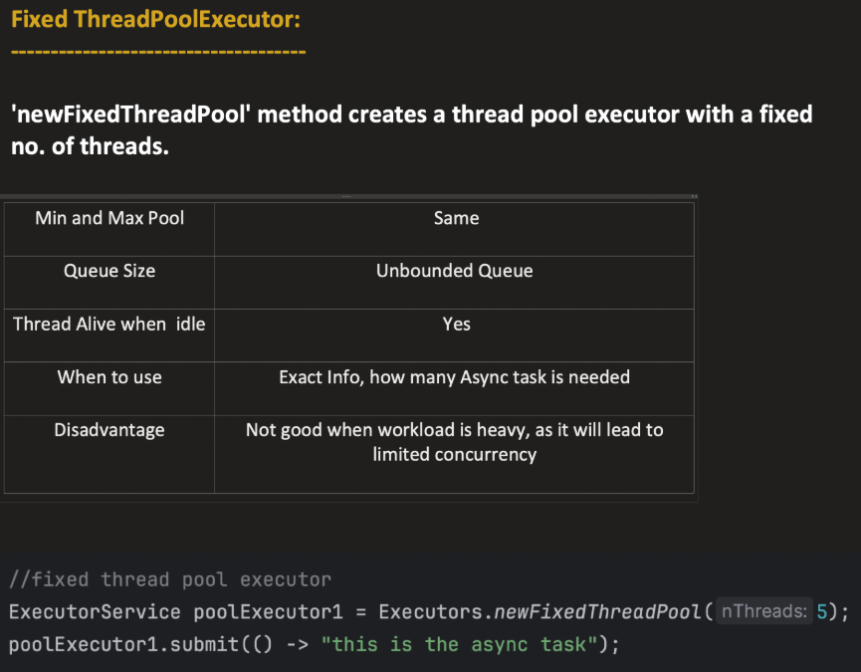

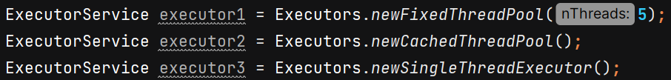

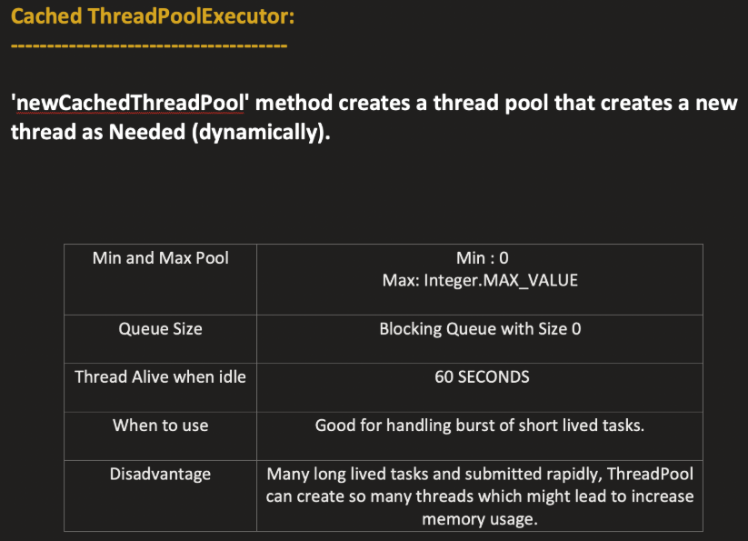

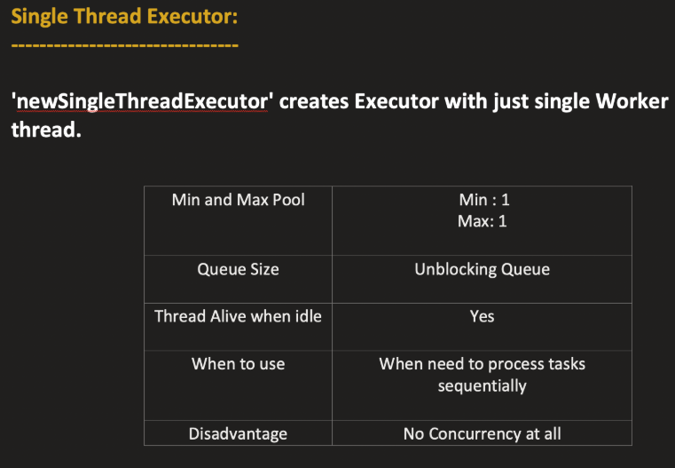

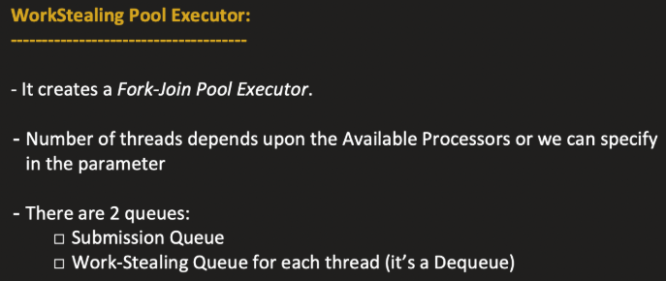

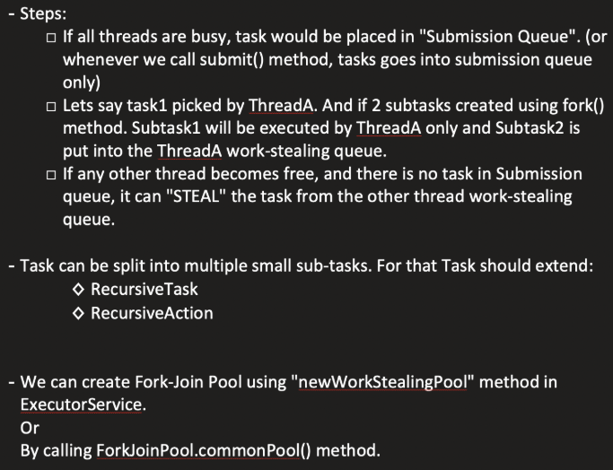

* We can **divide bigger task into smaller tasks using fork()**
* and then **wait for them to complete using join()** and ultimately return the final result.

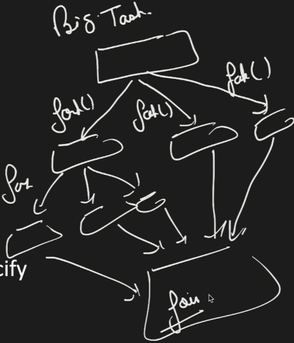 The purpose is to bring more parallelism by dividing bigger task so multiple threads can execute each subtask and club the results together.

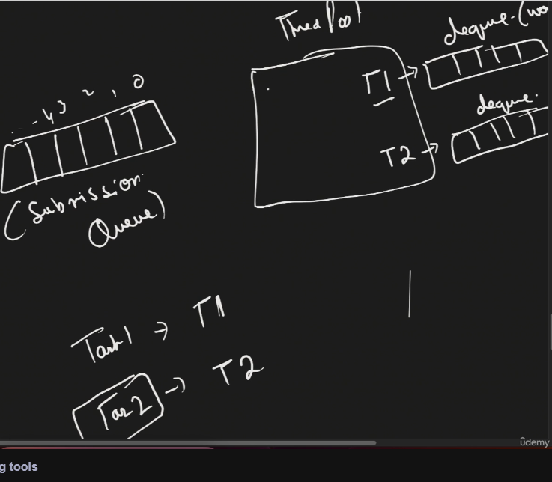 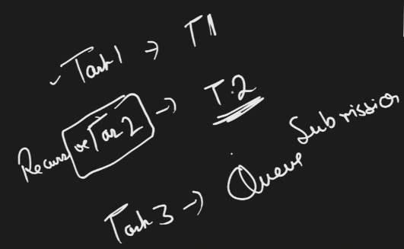

In WorkStealing pool, each thread maintains its own dequeue (work-stealing queue).

* Suppose Task1 comes its picked by T1 and started executing.
* Task2 comes, it can be divided into subtasks and T2 picks it. T3 comes, it is put into Submission queue.
* Suppose T2 divides task2 into subtask1 and subtask2, then T2 will start working on subtask1 and put subtask2 in its work-stealing queue.
* Suppose T1 completes Task1 and its free, so next **it will first check its own work-stealing queue if any subtask present? Then its will check Submission queue**

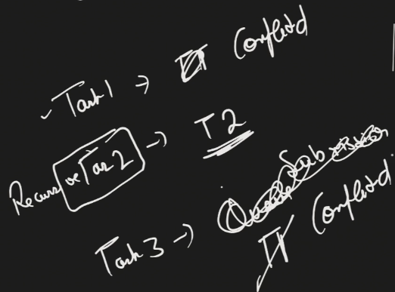 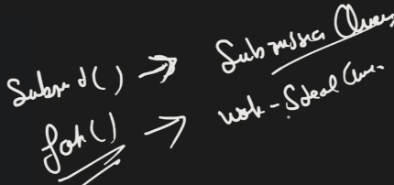

* T1 picks Task3 from Submission queue and complete it. T2 is still busy with subtask1 of Task2.

Now T1 will again see –

1. Check its own work stealing queue if any subtask present?
2. Check submission queue if any task waiting?
3. Can I steal a subtask from busy thread’s work-stealing queue

So T1 will steal the substask2 of Task2 from work-stealling queue of T2 and put that subtask in its own work-stealing queue and starts working on it.

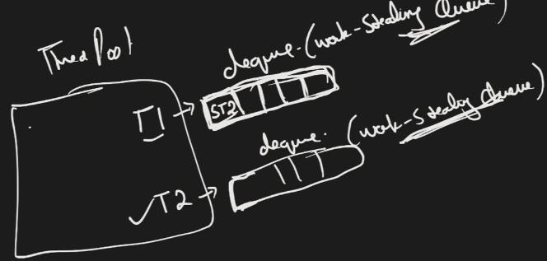

* It uses dequeue becoz whenever any thread try to steal subtasks, it will steal it from back and thread T2 will consume its subtasks from front.

Whenever ur subtask need to return anything 🡪 go for **RecursiveTask**

Whenever it does not return any value 🡪 **RecursiveAction**

Ex- Task is to compute sum from start to end.

Whenever u do fork(), means u are dividing the task into multiple subtasks, in which 1 subtask the same thread is gonna pick and put other subtasks into its work-stealling queue which can be stolen by some other thread which is free.

With join() we get the result of subtask.

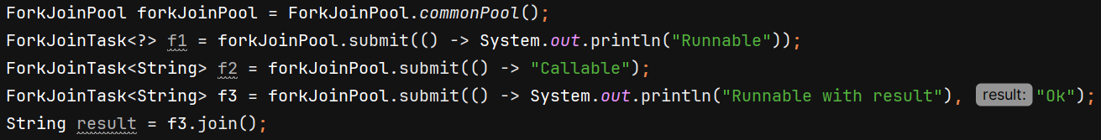

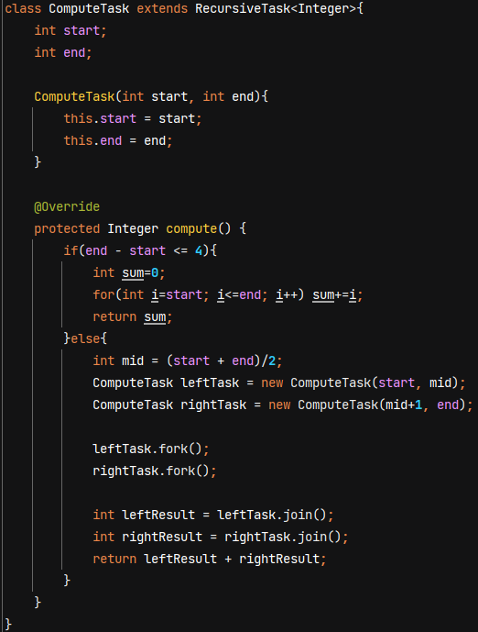 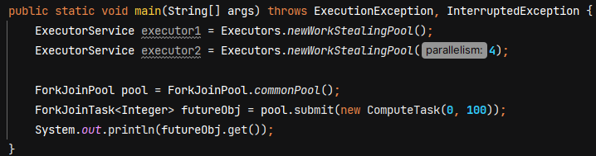

**ThreadLocal**

ThreadLocal is a Java class that provides thread-confined storage, giving illusion that each thread accessing the ThreadLocal variable has its own independent copy of the variable. So, changes made by one thread are **not visible** to others.

**Working** – No separate copy of ThreadLocal variable is created; instead, each Thread has its own ThreadLocalMap object storing key-value pairs where key is ThreadLocal and value can be any object.

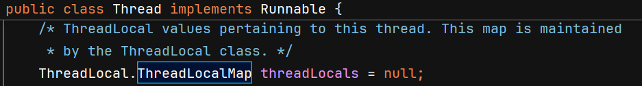

When we call set() method using ThreadLocal object, it first fetch the ThreadLocalMap of that thread and set value using key as the object itself –

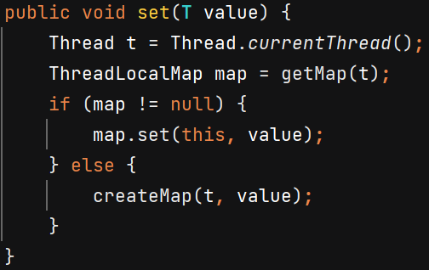 get() method fetch data from current thread ThreadLocalMap.

**Note** – **ThreadLocalMap use weak references for keys** 🡪 To prevent memory leaks when ThreadLocal objects are no longer referenced but threads are still alive. So once the ThreadLocal object is garbage collected, the key in map entry becomes null. The value associated with that entry is only removed when the thread explicitly calls ThreadLocal.remove() method on the corresponding ThreadLocal instance.

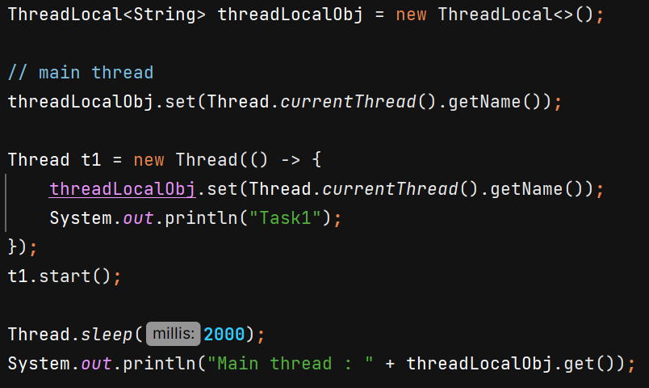 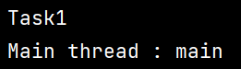

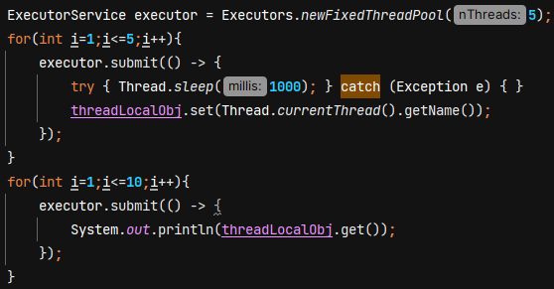 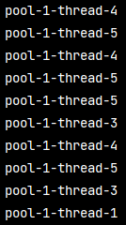

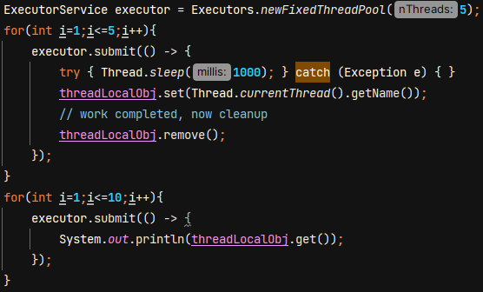 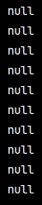

**Virtual Thread** 🡪 Lightweight threads introduced to get higher throughput not reduce latency. Ideal for I/O bound tasks. We can create thousands of virtual threads.

Throughput – in 1 second how many tasks can you perform.

Latency – time taken for a single request to travel from start to finish. Its like the delay u experience when u ask system to do something.

Platform thread (what Java calls Thread) is managed by JVM which is like wrapper around native/OS thread. So if you are creating 10 threads, then those 10 threads are 1-1 mapped with OS threads.

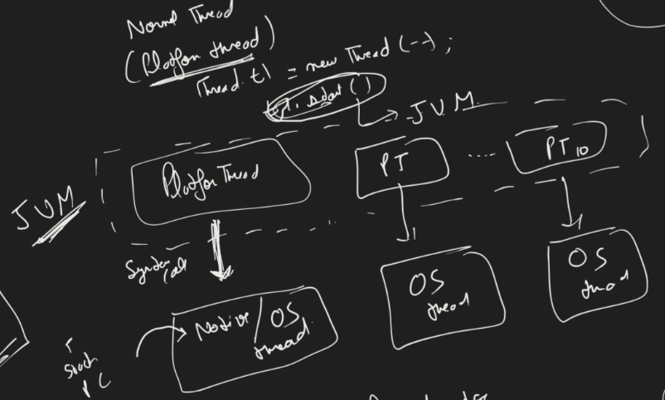

Disadvantage –

1. Its slow becoz thread creation takes time. **When u call th1.start() u r trying to create one thread and JVM asks OS to create 1 native/OS thread**. This is a system call and it takes time.
2. Suppose ur thread is waiting for certain DB call which takes 4 sec. So ur thread is in waiting state and due to 1-1 maping the OS thread also gets blocked. Waste of Resource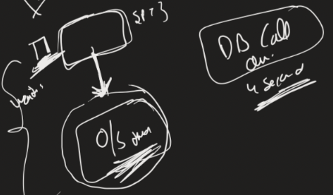

**WORKING 🡪** If any virtual thread which wants to execute and not in waiting state, then only it would be attached to OS thread. And if it wants to go into waiting state, then JVM will detach the link between OS thread and virtual thread. And any other virtual thread which wants to run, its linking would be done.

So there is no 1-1 mapping between virtual thread and OS thread. Apart from this all the functionalites are backward compatible and we can apply all multithreading concepts. Only difference is how JVM is managing the thread.

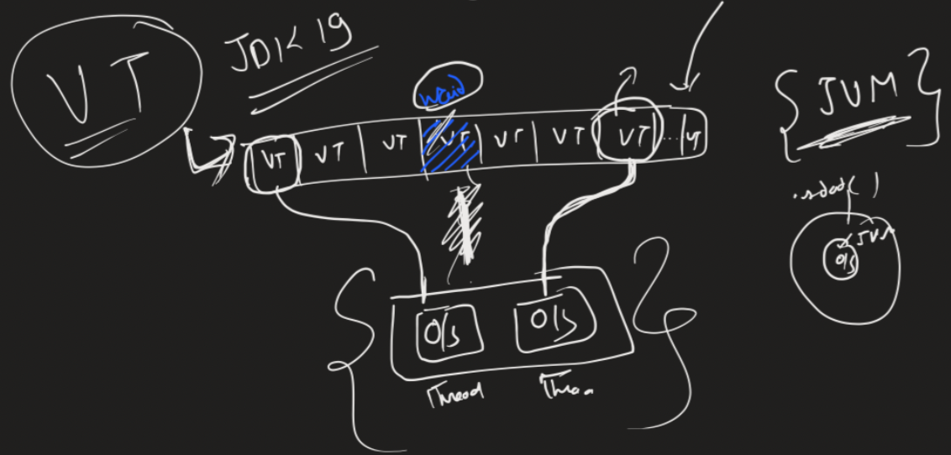

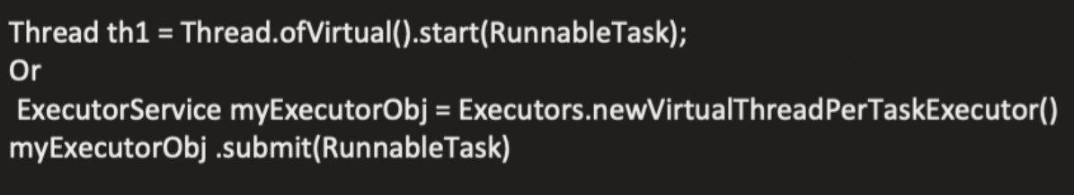

**Volatile vs Atomic**

Volatile 🡪 **read and write should happen directly to main memory**.

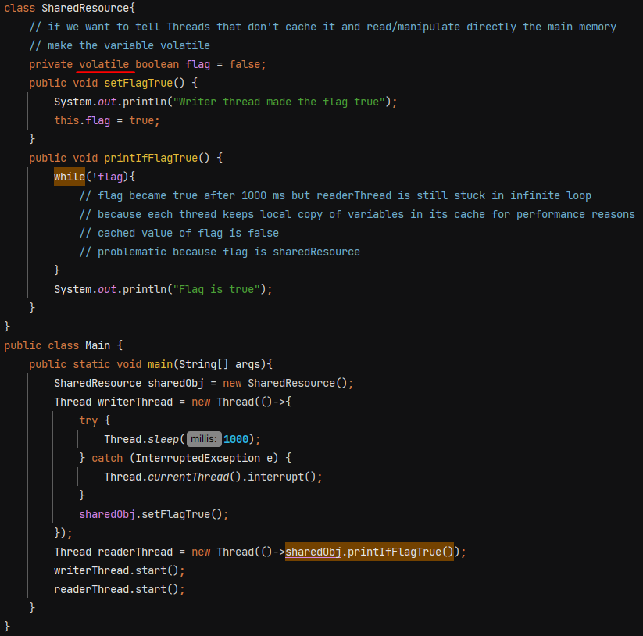

If we don’t make variable volatile then readerThread is stuck in infinite loop.

**🡺 Volatile has no relation with concurrency. It is not thread-safe.**

**🡺 All fields being read in a synchronized block will be read from main memory.**

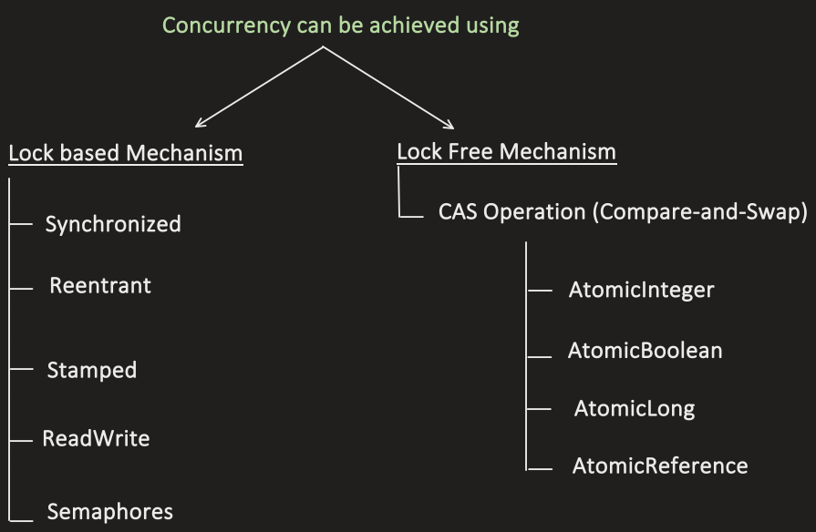 AtomicReference is used for Objects

Concurrency can be achieved using **Lock Free Mechanism (Compare And Swap)** which is faster but its usecase is very specific. It is not alternative to Lock based mechanism.

Optimistic concurrency control is inspired by CAS but its mostly used in DB operations whereas CAS used in low level cpu operations.

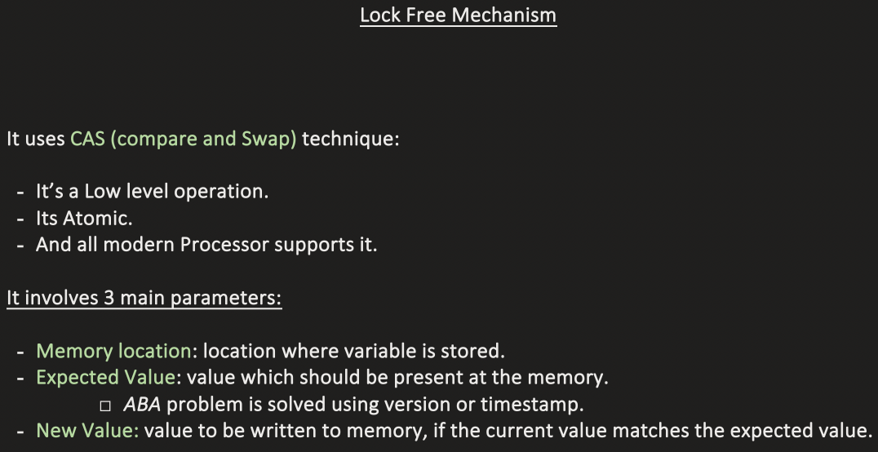

**Atomic** :- 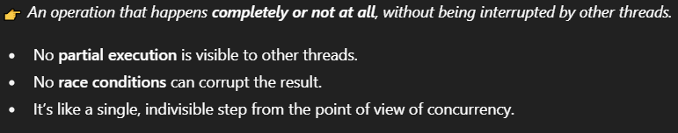

AtomicInteger, AtomicLong, AtomicBoolean - does not use locks. It achieves thread safety using **non-blocking, lock-free algorithm CAS** that rely on **low-level hardware support** for atomic operations.

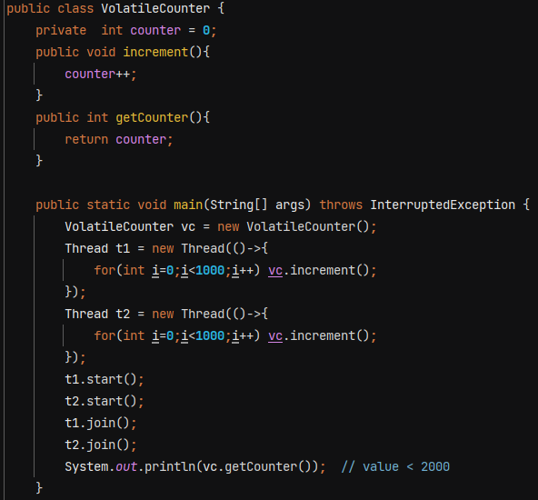

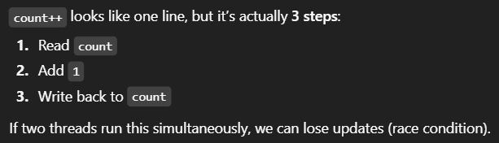

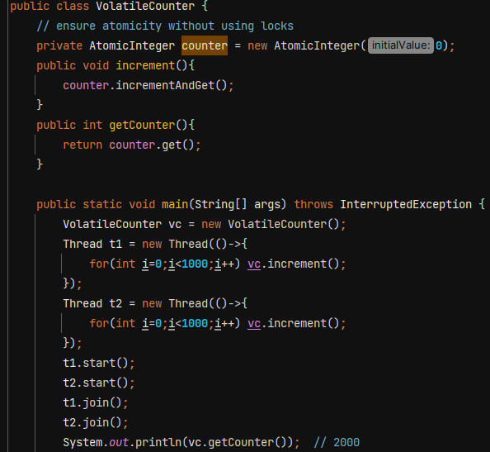

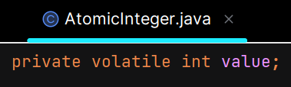 value is read directly from main memory during CAS operation.

Inside **incrementAndGet()** method we do something like this -

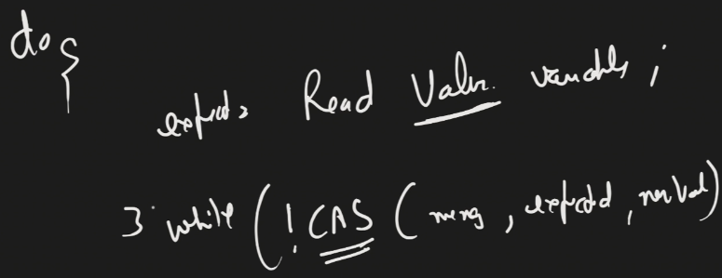

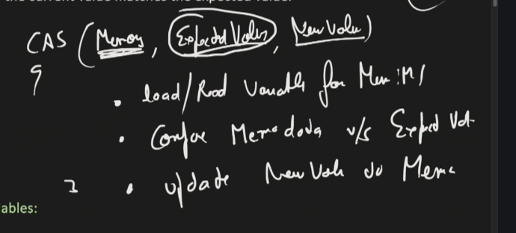

Till CAS operation is not success, thread will continue to try. CPU ensures CAS is atomic and only 1 threads can perform it on the same memory location.

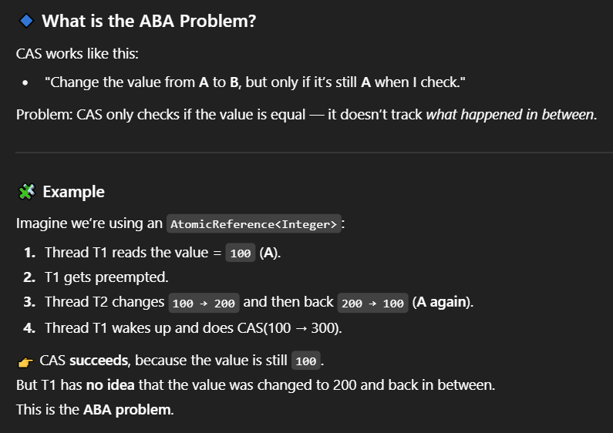

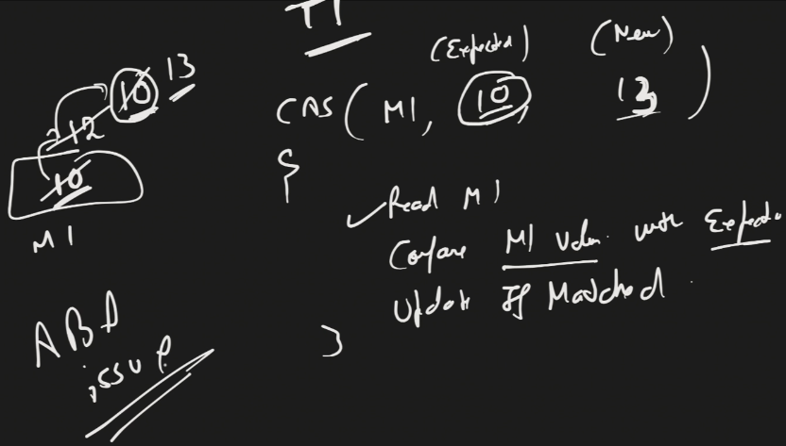

This problem is solved by using stamp/version with value –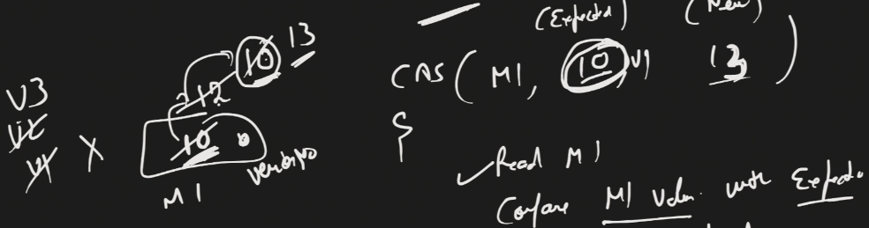

V1 != V3 so value does not get updated.

Java provides **AtomicStampedReference** for this.

**CountDownLatch** – It allows one or more threads to wait for a set of operations being performed by other threads to complete before proceeding further.

**count –** the number of times countDown must be invoked before threads can pass through await

Ex- we want to achieve that our main thread wait for some other dependent services.

Without – 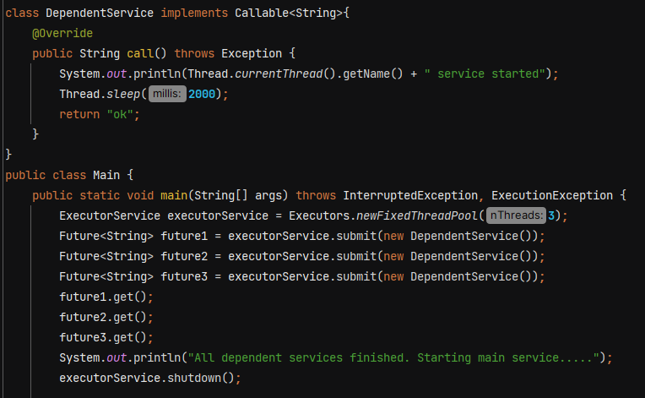

**With CountDownLatch –** 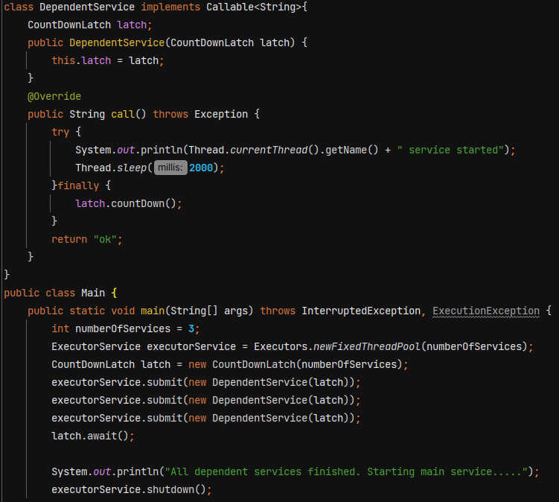

O/P 🡪 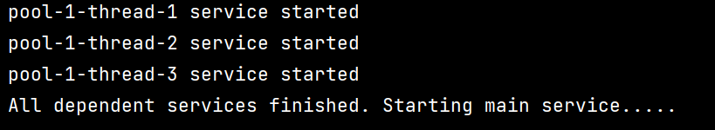

**Using threads –**

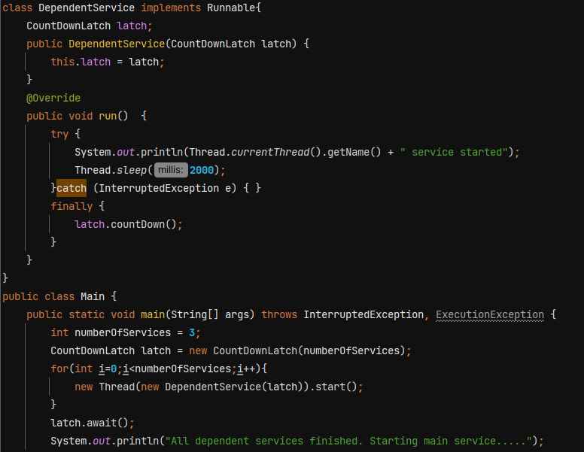

O/P 🡪 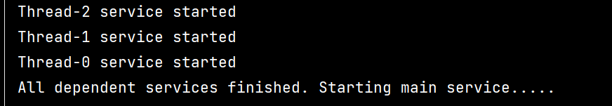

**await()** 🡺 Causes the current thread to wait until the latch has counted down to zero, unless the thread is interrupted.

We can also pass timeout like **await(5, TimeUnit.SECONDS)** 🡪 wait for 5 second and then start executing main thread.

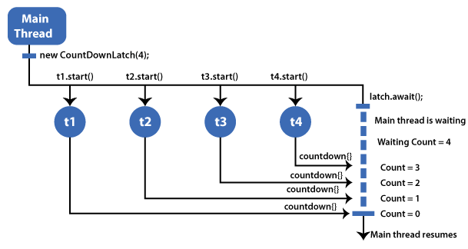

**CyclicBarrier** –

In cyclic barrier, multiple threads waits at barrier until all of them reached barrier. When the last thread reaches the barrier then all threads are released.

* **It does not block main thread.**
* It is used to make sure that certain no of threads reach at a particular point before any of them proceed.
* It is reusable whereas CountDownLatch is not reusable, once the count reaches 0 it cannot be reset.
* It **automatically resets itself** after all participating threads have reached the barrier.

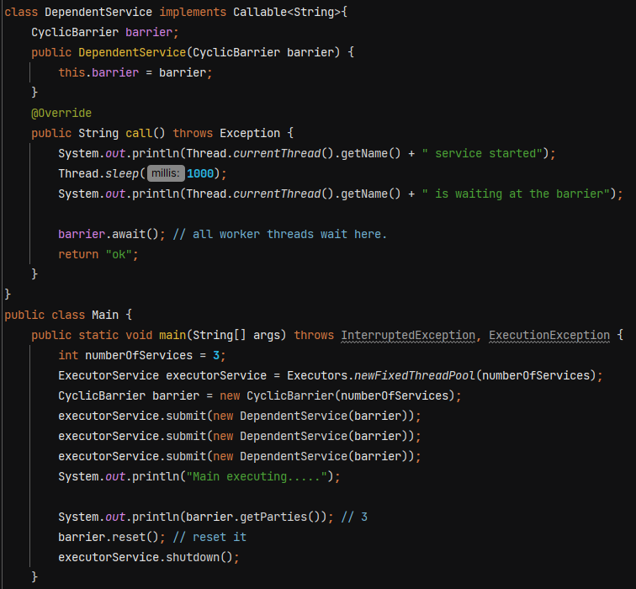

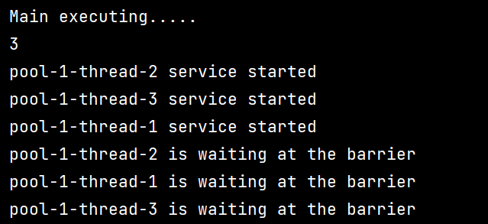

**await()** 🡺 Waits until all parties have invoked await on this barrier.

**getParties()** 🡺 Returns the number of parties required to trip this barrier.

**reset()** 🡺Manually resets the barrier to its initial state.

Suppose barrier requires 3 threads, only 2 threads call await() and start waiting. Another thread resets the barrier then all waiting threads will get BrokenBarrierException.

If you want main thread to wait –

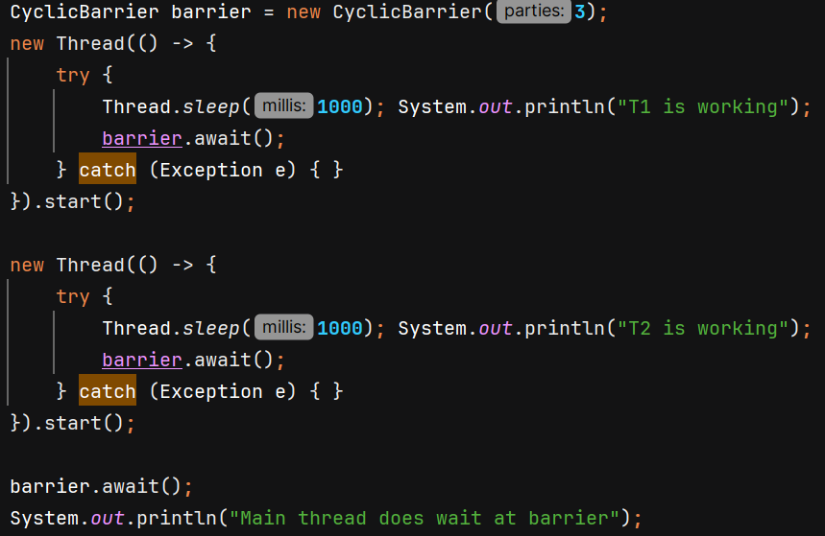 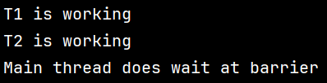

We can pass barrierAction Runnable in argument which is executed when all the waiting threads reach the barrier. It is performed by the last thread reaching barrier.

